POPULATION DYNAMICS OF RHIZOBIUM JAPONICUM
AND RHIZOBIUM LEGUMINOSARUM IN HOST
AND NON-HOST RHIZOSPHERES

A THESIS SUBMITTED TO THE GRADUATE DIVISION OF THE
UNIVERSITY OF HAWAII IN PARTIAL FULFILLMENT
OF THE REQUIREMENTS FOR THE DEGREE OF

MASTER OF SCIENCE
IN AGRONOMY AND SOIL SCIENCE
DECEMBER 1982

By
Robert Baines Woolfenden II

Thesis Committee:
B. Ben Bohlool, Chairman
Mitiku Habte
Jake Halliday

We certify that we have read this thesis and that in our opinion it is satisfactory in scope and quality as a thesis for the degree of Master of Science in Agronomy and Soil Science.
ACKNOWLEDGEMENTS

I am very grateful to Dr. B. Ben Bohlool for his guidance, constructive criticisms, enthusiasm, and patience throughout all phases of this research.
In addition, I am grateful to fellow graduate students,
Mark Kingsley, Renee Kosslak, Michael Sadowsky, and Paul Singleton, for helpful suggestions and encouragement as the experiments progressed.
This work was supported in part by Grant AID/ta-C-1207 (NifTAL Project) from the United States Agency for International Development. The conclusions reached within this study do not necessarily represent the views of the granting agency.
TABLE OF CONTENTS
Page
ACKNOWLEDGEMENTS ............................................... 3
LIST OF TABLES ................................................. 5
LIST OF FIGURES ................................................ 6
LIST OF DIAGRAMS ............................................... 8
CHAPTER 1. INTRODUCTION AND LITERATURE SURVEY ................. 9
CHAPTER 2. POPULATIONS OF RHIZOBIUM IN THE RHIZOSPHERES
OF HOST AND NON-HOST PLANTS AT HARVEST ............. 25

CHAPTER 3. POPULATIONS OF RHIZOBIUM IN THE RHIZOSPHERES
OF HOST AND NON-HOST PLANTS DURING A 35-DAY
GROWTH CYCLE ....................................... 52

CHAPTER 4. RHIZOBIUM POPULATION DYNAMICS IN HOST AND
NON-HOST RHIZOSPHERES DURING THE FIRST
NINE DAYS OF RHIZOSPHERE DEVELOPMENT ............... 89

CHAPTER 5. GENERAL DISCUSSION ................................. 111
LIST OF TABLES

Page

TABLE

2-1 Comparison of the recovery of added Rhizobium
from Kula loam soil by two methods ................. 36

4-1 Percentages of Rhizobium inoculant strains
(combined) in the total rhizosphere population
of bacteria at 3, 5, 7, and 9 days ................. 104

4-2 Percentages of Rhizobium inoculant strains
(combined) in the total rhizosphere population
of bacteria at planting, 24, and 48 hours .......... 105
LIST OF FIGURES

Page

FIGURE

2-1 Counts of 4 Rhizobium strains at harvest 1 .......... 37

2-2 Counts of 4 Rhizobium strains at harvest 2 .......... 38

2-3 Counts of 4 Rhizobium strains at harvest 3 .......... 39

2-4 Counts of 4 Rhizobium strains at harvest 4 .......... 40

2-5 Acridine orange total counts of bacteria
at harvests 2, 3, and 4 ............................. 41

2-6 Soybean nodule occupancy by Rhizobium
japonicum strains ................................... 42

2-7 Pea nodule occupancy by Rhizobium
leguminosarum strains ............................... 44

2-8 R. japonicum nodule bacteria, stained
with homologous fluorescent antibody ................ 46

2-9 R. leguminosarum nodule bacteria, stained
with homologous fluorescent antibody ................ 46

3-1 Counts of 4 Rhizobium strains per gram of
soil at 1 week ...................................... 64

3-2 Counts of 4 Rhizobium strains per gram of
soil at 2 weeks ..................................... 65

3-3 Counts of 4 Rhizobium strains per gram of
soil at 3 weeks ..................................... 66

3-4 Counts of 4 Rhizobium strains per gram of
soil at 4 weeks ..................................... 67

3-5 Counts of 4 Rhizobium strains per gram of
soil at 5 weeks ..................................... 68

3-6 Counts of 4 Rhizobium strains per square
centimeter of root area at 1 week ................... 69

3-7 Counts of 4 Rhizobium strains per square
centimeter of root area at 2 weeks .................. 70

3-8 Counts of 4 Rhizobium strains per square
centimeter of root area at 3 weeks .................. 71

3-9 Counts of 4 Rhizobium strains per square
centimeter of root area at 4 weeks .................. 72
LIST OF FIGURES (Continued)

Page

FIGURE

3-10 Counts of 4 Rhizobium strains per square
centimeter of root area at 5 weeks ....................... 73

3-11 Acridine orange total counts of bacteria per
gram of soil over 5 weeks ................................ 74

3-12 Acridine orange total counts of bacteria per
square centimeter of root over 5 weeks ................... 75

3-13 Soybean nodule occupancy by R. japonicum
strains .................................................. 77

3-14 Large pea nodule occupancy by R. leguminosarum
strains .................................................. 78

3-15 Small pea nodule occupancy by R. leguminosarum
strains .................................................. 79

3-16 View of the experiment at 1 week ......................... 81

3-17 View of the experiment at 3 weeks ........................ 83

3-18 View of the experiment at 5 weeks ........................ 83

4-1 Counts of 4 Rhizobium strains at 3 days .................. 96

4-2 Counts of 4 Rhizobium strains at 5 days .................. 97

4-3 Counts of 4 Rhizobium strains at 7 days .................. 98

4-4 Counts of 4 Rhizobium strains at 9 days .................. 99

4-5 Acridine orange total counts of bacteria
at 3, 5, 7, and 9 days ................................... 100

4-6 Counts of 4 Rhizobium strains in the pea
rhizosphere at planting, 24, and 48 hours ................ 101

4-7 Counts of 4 Rhizobium strains in the soybean
rhizosphere at planting, 24, and 48 hours ................ 102

4-8 Acridine orange total counts of bacteria in
the pea and soybean rhizopheres at planting,
24, and 48 hours ......................................... 103
LIST OF DIAGRAMS

Page

DIAGRAM

3-1 Positioning of watering device, and setup of
experimental pot for watering from below ................. 59

3-2 Arrangement of cores and order of harvest for
the 35-day time course study ............................. 60

CHAPTER 1
INTRODUCTION AND LITERATURE SURVEY
INTRODUCTION AND LITERATURE SURVEY

The increasing disparity between population growth and food production has placed a burden on agriculturalists to devise more efficient methods of food production. Therefore, the Rhizobium-legume symbiosis has received renewed attention lately, as it becomes more and more apparent that we cannot count on cheap fossil fuels to supply our needs for fixed nitrogen. There has been a renascent interest in biological nitrogen fixation in general, and in the Rhizobium-legume symbiosis in particular, as a means to help provide protein to the world’s rapidly-expanding population.
The symbiosis is a partnership between soil bacteria of the genus Rhizobium and plants of the family Leguminosae. The visual manifestations of the symbiosis are legume root nodules which house the rhizobia. Inside these nodules atmospheric dinitrogen gas is enzymatically reduced initially to ammonia, thereby entering the assimilation pathways of plants.
The term “rhizosphere” was coined by Hiltner in 1904 as “the region of contact between soil and root, where the soil is affected by the root”.
Before any nodules are formed, however, a series of intricate events occurs in the rhizosphere. Rhizobia multiply in the host rhizosphere, somehow recognize the plants’ roots as those of a host legume, infect those roots, and eventually initiate nodule formation. Specificity is the hallmark of the Rhizobium-legume symbiosis; only certain species of rhizobia are able to infect the roots of particular legume species. Although the relationship between the bacteria and the host legume has been studied in great detail, as yet the basis for this specificity is not clear.
A number of authors (Bohlool and Schmidt, 1974; Dazzo and Hubbel, 1975) have implicated lectins (sugar-specific proteins or glycoproteins on the legume root surface) as a possible basis for specificity. However, due to the lack of standardized techniques for examining lectin binding, the notion of lectin-mediated specificity is still controversial (Broughton, 1978, Schmidt, 1979).
Another possible contributor to specificity is the stimulation of the growth of rhizobia in the rhizosphere of their homologous host plants, over and above that of the normal rhizosphere flora, and over other non-homologous rhizobia (Nutman, 1963, 1965). This specific stimulation in the rhizosphere has been postulated to be mediated by root exudates. Selective stimulation of rhizobia by the roots of their legume hosts would be of great selective advantage to both, and presumably could be operating in concert with lectins to confer specificity to the symbiosis.
The objective of this chapter is to give a concise review of the pertinent literature on the effects of root exudates on rhizobia, and to examine specific stimulation by those exudates as a possible contributor to specificity in the symbiosis.
Plant roots in general stimulate gram negative rods more than other soil bacteria; and these constitute greater proportions of the rhizosphere than the soil populations in general (Rovira and
McDougall, 1967). Krasil’nikov (1958) demonstrated that bacteria which colonize the rhizosphere of one plant species do not necessarily colonize that of other plant species. He also showed that not all strains of Pseudomonas fluorescens have equal rhizosphere colonizing abilities. One of the most consistent differences between bacteria isolated from the rhizosphere and those isolated from fallow soil is the requirement of the former for amino acids (Lochhead and Rouatt, 1955).
Starkey (1929) suggested the following factors to be involved in the stimulation of microorganisms by plant roots; sloughed-off root cells, moribund root hair and cortical cells, and soluble organic nutrients released or actively exuded by intact roots. Much evidence has been presented demonstrating the exudation of many organic materials from healthy, intact plant roots (Scroth and Hildebrand, 1964; Rovira, 1962; 1965). These studies support the notion that sufficient nutrients are exuded to support large rhizosphere populations of microorganisms.
The legume rhizosphere has shown to be a particularly intense zone of microbial activity, due to the nature and quantity of products exuded by legume roots (Rovira, 1956a; 1962). According to the theory of specific stimulation, legume exudates should stimulate rhizobia able to infect them more than other rhizobia. This theory was detailed by Nutman (1965).
Most of the early studies were conducted in aseptic solution, agar, or sand culture, using one or a few strains of Rhizobium. The following is a chronological review of some of the early studies.
Nutman (1953) grew clover, alfalfa, and vetch, singly and in pairs consisting of either one or two plant species. Plants were cultured aseptically in tubes on agar “slopes”. In these experiments the presence of an alfalfa plant in the same tube with a clover plant and R. trifolii, plants were nodulated sooner than in tubes in which there were two clover plants. Apparently, exudates from the alfalfa roots were able to stimulate the nodulation of clover. Exudates from inoculated clover plants uniformly inhibited the nodulation of another clover, lucerne, or vetch plant in the same tube. This inhibition was least in clover and greatest in vetch. Inhibition of nodule formation on clover was obtained in tubes which had been preplanted with clover and the earlier plantings removed. Nutman interprets his results in terms of the secretion of some nodule-inhibiting substance from the clover roots.
Several of the early examinations of plant root exudates in the rhizosphere were carried out by Rovira (1956a, 1956b, 1961; Rovira and Harris, 1961). In many of his studies, plants were cultured in sterile sand, instead of the sterile water or agar culture used by several workers previously. Following growth, plants were carefully removed, and exudates leached out of the sand. Rovira (1956a) demonstrated the exudation of a host of amino compounds and sugars from aseptically-grown oat and pea plants. Exudates from pea roots were larger in quantity, and compounds were more numerous and varied than those from the roots of oats. Early studies had been complicated by the fact that only a small amount of rhizosphere soil was available for study. To get around this problem, Rovira (1956b) established an “artificial rhizosphere” in which non-sterile field soils were saturated with root exudate solution collected from aseptically-grown roots. Treatment was continued for 21 days, and an overall stimulation of bacterial growth upon the addition of the exudates, the bacteria consisting largely of gram negative rods, was taken as evidence that his artificial rhizosphere had actually been successful. The resulting populations of root-exudate-treated soils did not increase the rate of organic matter decomposition in the soil. However, the artificial rhizosphere population did promote the decomposition of the more readily-available organic nutrients, such as amino acids and glucose. Rovira (1961) compared the rhizospheres of red clover and paspalum (a grass) with respect to numbers of R. trifolii and total bacteria. In this study, non-sterile field soil was used, and Rhizobium numbers were determined by the most probable number (MPN) technique (Vincent and Waters, 1954). Bacterial numbers were examined in response to the rhizospheres of the two plant species and also to varying lime levels. Bacteria, including rhizobia, were consistently present in larger numbers in the rhizosphere of clover than that of paspalum; ratios for Rhizobium were about 5:1 (clover: paspalum) and for total bacteria, about 2:1. Liming was beneficial to the rhizosphere populations of both plants. The liming probably affected the growth of the microorganisms directly and also indirectly, by first enhancing plant growth and root exudation. In a further study, Rovira and Harris (1961) examined the exudation of growth factors from peas, alfalfa, tomato, and several clover species grown in sterile sand culture. Their aim was to quantitatively assess the various B-group vitamins exuded by these plant species. Biotin was found to be exuded in the largest quantity, and was found in the rhizosphere of pea at 10 to 100 times the concentration found in clover or tomato rhizospheres. Other growth factors, notably pantothenate and niacin, were present, but in amounts considered by the authors as unlikely to influence the growth of microorganisms. In non-sterile sand culture, biotin and pantothenate were seen to disappear rapidly, emphasizing the need for strict asepsis in any studies of root exudates.
Studies by Rovira and coworkers emphasized the large variety and quantity of substrates exuded by plant roots, particularly those of legumes. However, most of these studies focused on the exudates themselves rather than the particular bacteria stimulated by those exudates. Because of this fact, most studies were carried out under aseptic conditions in sand culture.
Elkan (1961) examined a non-nodulating, near isogenic soybean variety to determine the reason for non-nodulation. In greenhouse solution culture, he demonstrated that the root excretions from the mutant non-nodulating line resulted in highly significant (p=.01) decreases in nodulation of normal, nodulating plants. In addition, the excretion resulted in decreased total nodule weight, total dry weight, and total nitrogen per nodulating plant. Curiously, the excretion did not inhibit growth of R. japonicum directly, nor did it inhibit nodulation of other plant species by other rhizobia.
Tuzimura and Watanabe (1962a) examined the populations of bacteria, fungi, actinomycetes, and specifically Agrobacterium radiobacter and a Rhizobium spp. from Astragalus sinicus in the rhizosphere of this plant. Anon-sterile volcanic ash soil was used, and rhizobia were enumerated by an MPN method. The astragalus plants were able to support a reasonable population of astragalus rhizobia, about 8.1 x 10⁴ at flowering, and 10⁸ per gram dry root at fruiting, regardless of starting Rhizobium population. In a further study, Tuzimura and Watanabe (1962b) followed populations of R. trifolii in the rhizospheres of several leguminous plants, as well as the rhizospheres of non-legumes. Ladino clover, alfalfa, soybean, and peanut were the legumes examined. The non-legumes were sudan grass and upland rice. Rhizobium trifolii were consistently seen in larger numbers in the rhizosphere of alfalfa, followed by peanut, followed by soybeans, and, followed by clover. No statistical treatment of the data was presented, and the authors state that “these findings might not be necessarily valid, because the growth of the plants and contents of soils which adhered to the root varied in each case.” Rhizosphere numbers of R. trifolii were, without exception, at least two logs greater in the rhizosphere of legumes than in non-legume rhizospheres.
Nutman (1963, 1965) suggested that “A given legume tends to promote the multiplication of bacteria able to infect it more than others”, and, “Individual strains of nodule bacteria are more strongly stimulated by those hosts they are able to infect than by other legumes”, citing only a reference by Wilson (1930) in support of these statements. Dart and Mercer (1964) present the opposite viewpoint. They state that there is no evidence that legume roots selectively stimulate the growth of Rhizobium rather than other organisms. Further, they state that the Rhizobium strains which nodulate a particular legume are not preferentially stimulated in that hosts rhizosphere over other Rhizobium strains, citing Krasil’nikov (1958) and Purchase (private communication).
Rovira (1965) concluded that sufficient chromatographic analyses had been performed on root exudates to indicate the wide spectrum of compounds contained therein.
Peters and Alexander (1966) examined four different rhizobia in the rhizosphere of alfalfa and Lotus corniculatus in aseptic solution culture. Alfalfa was inoculated with R. meliloti, R. trifolii, and
R. leguminosarum to see if alfalfa stimulated only its homologous Rhizobium, R. meliloti. Despite differences in initial inoculum size and in spite of the fact that R. meliloti alone induced nodulation, populations of all rhizobia reached roughly 10⁶ to 10⁷ cells/ml of rooting medium after 1 week, and following that cell numbers did not fall rapidly. These results, albeit in aseptic solution culture, were not suggestive of specific stimulation. Also, when alfalfa and Lotus corniculatus were inoculated with a mixed culture of their respective microsymbionts, no selective interaction between host and homologous organisms was seen. Peters and Alexander (1965) suggested that the selectivity between microbe and host is probably exerted first at individual receptor sites on host root surfaces.
Van Egeraat (1975a) examined the growth of R. leguminosarum on the rhizoplane (root surface) and in the rhizosphere of aseptically growth pea seedlings, using sterile agar culture in petri plates. He observed no bacterial growth on the main taproot, however, after the emergence of secondary roots bacterial numbers increased where the secondary roots emerged from the main taproot. Lateral roots of the pea seedlings growing in sterile agar along the bottom of the petri dish had a zone of bacterial growth some distance from the roots. Van Egeraat (1975a) attributed this to a zone of growth inhibition surrounding roots more closely. Of particular interest in this study was the stimulation of rhizobia around the sites of emergence (“wounds”) of the lateral roots. Van Egeraat concludes that young pea plants exude both growth stimulating and growth-inhibiting compounds. Further, the growth-inhibiting compounds can temporarily prevent the growth of R. leguminosarum in the immediate vicinity of the pea roots. In a follow-up study, Van Egeraat (1975b) demonstrated that R. leguminosarum grew equally well with homoserine and glutamic acid as the nitrogen source, or as the sole source of carbon, nitrogen, and energy. Strains of R. trifolii, R. phaseoli, and R. meliloti behaved entirely differently. These three strains could grow with glutamate as the only C and N source. With homoserine, growth was extremely slow or absent, or in the case of R. meliloti, considerably reduced. Van Egeraat suggested that homoserine (which was found to comprise about 70% of the amino compounds exuded by pea roots) might selectively stimulate the growth of R. leguminosarum in the pea rhizosphere when a mixture of Rhizobium of many species is present. This represents perhaps the most compelling study in favor of specific stimulation. However, it was carried out under totally aseptic conditions, and on the basis of these experiments it would be impossible to predict the fate of homoserine in the rhizosphere of pea plants grown in the field. Homoserine is the first compound to be suggested as a specific stimulant in the scientific literature. Rovira (1965) stated that it would appear unlikely that the ubiquitous sugars and amino acids would provide the specificity observed in the symbiosis, but rather the balance of these compounds of the presence of exotic compounds peculiar to a particular plant species. Van Egeraat (1975b) states that in the pea system, just such a compound, homoserine, is present.
The studies on root exudates and the rhizosphere effect with respect to rhizobia have either addressed the interaction in aseptic systems, from which organisms can be conveniently plated and counted, or have enumerated rhizobia indirectly by means of MPN counts (in the case of non-sterile systems). However, either method has its share of disadvantages, and thus early studies of individual species or strains of Rhizobium in the rhizosphere of their homologous host plants are not without criticism. What was needed was an adequate methodology for strain-specific enumeration of rhizobia in natural non-sterile rhizospheres, in which the full range of microbe-to-microbe and plant-to-microbe interactions are taking place.
An autoecological approach, in which the numbers of several different Rhizobium strains in the rhizospheres of several host plants could be studied, is necessary to adequately address the problem. The only method adequate for the study of a specific microorganism directly in a natural soil environment is immunofluorescence (Schmidt, 1979; Bohlool and Schmidt, 1980).
Reyes and Schmidt (1979) used membrane filter immunofluorescence (Schmidt, 1974) to enumerate R. japonicum strain 123 in soil and in rhizospheres of Minnesota field-grown soybeans. Rhizosphere effects were modest. About 10⁴ to 10⁵ cells/gram of soil were observed in soil adhering to plant roots. A comparably slight rhizosphere effect was seen for corn. According to their data, strain 123 did not follow what they termed the “scenario” of specific stimulation. Further, these authors state that experimental support for the specific stimulation hypothesis is meager, especially in terms of rhizobial response to plant rhizospheres under natural soil conditions. In a further study, Reyes and Schmidt (1981) used membrane filter immunofluorescence for enumeration of, and immunofluorescence examination of strain USDA 123 on root surfaces of field-grown soybeans. Strain 123 was a consistent rhizosphere colonizer, but failed to multiply as rapidly as the root system developed under field conditions. Root surface populations declined from about 7 to 8 x 10² per square cm of root surface on day 9 to about 60 per square cm on day 26. Average calculated cell density per square cm was only a few hundred. They also examined the behavior of strain 123 in the rhizospheres of pot-grown soybeans. In this trial, cell numbers and root surface populations were monitored every 4 days, until nodule initiation. This greenhouse experiment confirmed the findings of the field experiment. Strain 123 was seen in numbers of a few hundred per square cm of root surface during early growth, and declined to less than 100 per square cm with more extensive root development. Also addition of a competing strain (USDA 138) had little effect on the development of strain 123 in the soybean rhizosphere. Even when 10 times as many 138 cells than 123 cells were added, cell densities of both stabilized at a few hundred per square cm of root surface, and each appeared to establish independently of the other. Immunofluorescence examination of unwashed roots revealed that both strains were sparsely distributed on root surfaces. Microscopic examination of the roots also revealed that rhizobia were seldom seen in microcolonies, but rather as single, double, or triple cells. In this study, no proliferation of Rhizobium was observed, even at the junction of lateral and tap roots where release of organic compounds is likely to occur due to the wounds caused by the emergence of secondary roots (Van Egeraat, 1975a). No evidence was obtained in support of specific stimulation as a prelude to nodulation. Strain 123 established in numbers roughly equal to those of 138, even though 123 forms the vast majority of the nodules. Performing rhizosphere counts on the basis of root surface area makes the lack of specific stimulation in the rhizosphere even more clear cut. Competitive advantages of strain 123 over strain 138 were not obvious, however. These studies by Reyes and Schmidt represent an important first step in examining rhizobia in natural non-sterile field soil rhizospheres.
Exudates are important in establishing and maintaining the rhizosphere population of microorganisms; bacteria in particular seem to respond to the soil conditions around plant roots. In aseptic systems, the interactions between exudates and bacteria (particularly Rhizobium) have been studied by many investigators. Results in sterile systems have been somewhat ambiguous. In autoecological studies done under natural field soil conditions, no evidence has to date been found in support of specific stimulation. However, no study has examined several different species of rhizobia in the rhizospheres of both homologous and non-homologous legumes. An appropriately-designed autoecological study such as this could adequately address the question of specific stimulation in the legume rhizosphere.
The basis for specificity in the Rhizobium-legume symbiosis is still a matter of debate. A better knowledge of this basis might ultimately help to extend nodulation and nitrogen fixation capability beyond the legumes to other grain crops, grasses, and cereals. Self-sufficiency for nitrogen would be a highly desirable trait for any crop plant.
BIBLIOGRAPHY

1. Bohlool, B. B. and E. L. Schmidt. 1974. Lectins: a possible basis for specificity in the Rhizobium-legume symbiosis.
Science 185:269-271.

2. Bohlool, B. B. and E. L. Schmidt. 1980. The immunofluorescence approach in microbial ecology. pp. 203-241. In Advances in
microbial ecology, Vol. 4. Plenum Publishing Corp., New York.

3. Broughton, W. J. 1978. Control of specificity in legumeRhizobium interactions. J. Appl. Bact. 45:165-194.

4. Dart, P. J. and F.V. Merecer. 1964. The legume rhizosphere. Archiv fur Mikrobiologie 47:344-378.

5. Dazzo, F. B. and D. H. Hubbel. 1975. Cross-reactive antigens and lectins as determinants of symbiotic specificity in the Rhizobium-clover association. Appl. Microbiol. 30:1017-1033.

6. Van Egeraat, A. W. S. M. 1975a. The growth of Rhizobium leguminosarum on the root surface and in the rhizosphere of pea seedlings in relation to root exudates. Plant and Soil 42:367-379.

7. Van Egeraat, A. W. S. M. 1975b. The possible role of homoserine in the development of Rhizobium leguminosarum in the rhizosphere of pea seedlings. Plant and Soil 42:381-386.

8. Elkan, G. 1961. A nodulation-inhibiting root excretion from a non-nodulating soybean strain. Can. J. Microbiol. 7:851-856.

9. Krasil’nikov, N. A. 1958. Soil microorganisms and higher plants. Moscow Academy of Sciences, USSR. English edition. National Science Foundation.

10. Law, I. J. and B. W. Strijdom. 1977. Some observations on plant lectins and Rhizobium specificity. Soil Biol. Biochem. 9:79-84.

11. Lochhead, A. G. and J. W. Rouatt. 1955. The “rhizosphere effect” on the nutritional groups of soil bacteria. Soil Sci. Soc. Am. Proc. 19:48-49.

12. Nutman, P. S. 1953. Studies on the physiology of nodule
formation. IV. The mutual inhibitory effects on nodule production of plants grown in association. Ann. Botany (London) 17:95-126.

13. Nutman, P. S. 1963. Factors influencing the balance of mutual advantage in legume symbiosis. pp. 51-71. In P. S. Nutman and B. Mosse (Eds.) Symbiotic Associations. Cambridge Univ. Press, Cambridge, England.
14. Nutman, P. S. 1965. The relation between nodule bacteria and the legume host in the rhizosphere and in the process of infection. pp. 231-247. In K. F. Baker and W. C. Snyder (Eds.) Ecology of soil-borne plant pathogens - prelude to biological control. Univ. Calif. Press, Berkeley.

15. Peters, R. J. and M. Alexander. 1966. Effect of legume root exudates on the root nodule bacteria. Soil Sci. 102:380-387.

16. Reyes, V. G. and E.L. Schmidt. 1979. Population densities of Rhizobium japonicum strain 123 estimated directly in soil and rhizospheres. App. Environ. Microbiol. 37:854-858.

17. Reyes, V. G. and E. L. Schmidt. 1981. Populations of Rhizobium japonicum associated with the surfaces of soil-grown roots. Plant and Soil 61:71-80.

18. Rovira, A. D. 1956a. Plant root excretions in relation to the rhizosphere effect. I. The nature of root exudates from oats and peas. Plant and Soil 7:178-194.

19. Rovira, A. D. 1956b. Plant root excretions in relation to the rhizosphere effect. III. The effect of root nodule exudate on numbers and activity of microorganisms in soil. Plant and Soil 7:209-217.

20. Rovira, A. D. 1961. Rhizobium numbers in the rhizospheres of red clover and paspalum in relation to soil treatment and numbers of bacteria and fungi. Aust. J. Agric. Res. 12:77-83.

21. Rovira, A. D. and J. R. Harris. 1961. Plant root excretions in relation to the rhizosphere effect. V. The exudation of B-group vitamins. Plant and Soil 14:119-214.

22. Rovira, A. D. 1962. Plant root exudates in relation to the rhizosphere microflora. Soils Fertilizers 25:167-172.

23. Rovira, A. D. 1965. Plant root exudates and their influence upon soil microorganisms. pp. 170-186. In K. F. Baker and W. C. Snyder (Eds.) Ecology of soil-borne plant pathogens -
prelude to biological control. Univ. Calif. Press, Berkeley.

24. Rovira, A. D. and B. M. McDougall. 1967. Microbiological and biochemical aspects of the rhizosphere. pp. 417-463. In
A. D. McLaren and G. F. Peterson (Eds.) Soil biochemistry. Marcel Dekker, New York.

25. Schmidt, E. L. 1974. Quantitative autoecological study of microorganisms in soil by immunofluorescence. Soil Sci. 118: 141-149.

26. Schmidt, E. L. 1979. Initiation of plant root-microbe interactions. Ann. Rev. Microbiol. 33:355-376.
27. Scroth, M. N. and D. C. Hildebrand. 1964. Influence of plant exudates on root-infecting fungi. Ann. Rev. Phytopathology 2: 101-132.

28. Starkey, R. L. 1958. Interrelations between microorganisms and plant roots in the rhizosphere. Bact. Rev. 22:154-168.

29. Tuzimura, K. and I. Watanabe. 1962a. The growth of Rhizobium in the rhizosphere of the host plant. Ecological studies of root nodule bacteria (part 2). Soil Sci. Plant Nutri. (Tokyo) 8:19-24.

30. Tuzimura, K. and I. Watanabe. 1962b. The effect of various plants on the growth of Rhizobium. Ecological studies of root nodule bacteria (part 3). Soil Sci. Plant Nutri. (Tokyo) 8:13-17.

31. Vincent, J. M. and L. M. Waters. 1954. The root nodule bacteria as factors in clover establishment in the red basaltic soils of the Lismore district, New South Wales. II. Survival and success
of inocula in laboratory trials. Aust. J. Agric. Res. 5:61-76.

32. Wilson, J. K. 1930. Seasonal variation in the numbers of two species of Rhizobium in soil. Soil Sci. 30:289-296.

CHAPTER 2
POPULATIONS OF RHIZOBIUM IN THE RHIZOSPHERES
OF HOST AND NON-HOST PLANTS AT HARVEST
ABSTRACT

The growth of two strains of R. japonicum (strains USDA 110 and CB 1809), and two strains of R. leguminosarum (strains Hawaii 5-0 and Nitragin 92A3) was followed in the rhizospheres of soybean, pea, and corn growing in non-sterile soil. Rhizosphere soil was sampled at 35 days over four successive growth cycles. The numbers of each strain were determined by membrane filter immunofluorescence, using strain-specific fluorescent antibodies. Nodule occupancy of the strains on their appropriate host was determined by immunofluorescence. No specific stimulation of rhizobia in the rhizospheres of their homologous host plants was observed. Counts of all strains, as well as total bacteria were generally in the following order: soybean rhizosphere> pea>corn>fallow soil. Strain CB 1809 occupied a slightly higher percentage of soybean nodules than USDA 110, whereas Nitragin 92A3 dominated Hawaii 5-0 in pea nodules. Fifteen percent of soybean nodules were doubly infected, as were 3.5% of pea nodules. The four strains together comprised 1.5 to 2.6% of the total rhizosphere bacteria of the legumes and 2 to 9% of the total bacteria in the corn rhizosphere. Rhizobia comprised 3 to 5% of the total bacteria in fallow soil. These data are not suggestive of an overwhelming increase of homologous rhizobia in the rhizospheres of their respective host legumes. Specific stimulation of growth of Rhizobium in the legume rhizosphere does not appear to be a contributor to specificity in the Rhizobium-legume symbiosis under the conditions of this study.
INTRODUCTION

Soil bacteria of the genus Rhizobium are recognized by their ability to form nitrogen-fixing nodules on the roots of many leguminous plants. Rhizobia are specific with respect to the hosts they nodulate. Only certain species of rhizobia are able to infect and nodulate the roots of particular legumes. Although the relationship between rhizobia and their host legumes has been studied in great detail, the basis for this specificity is not completely clear (5,20).
Several possible mechanisms have been advanced to account for specificity, involving both plant and bacterial components (5). Bacterial chemotaxis might affect rhizosphere populations, as might rhizosphere competence once rhizobia have arrived in the root zone (21). Cellular recognition between host and bacterium is considered by some as a mechanism for specificity. Plant proteins called lectins are thought to interact specifically with rhizobia at the root surface (3,9,22). Another proposed mechanism for specificity is the preferential growth of the appropriate rhizobia in the rhizospheres of their homologous host plants over and above that of other rhizobia (7,14,25).
Most studies of stimulation in the legume rhizosphere have been carried out in aseptic systems, from which rhizobia can be conveniently plated and counted (8,13,15). However extrapolation from aseptic conditions to non-sterile field soil, in which the full range of microbial interactions would be occurring, is unrealistic, and often erroneous.
An indirect method of enumerating rhizobia in non-sterile soil is the plant dilution assay (24). In this method, the plant itself is used as a selective agent, and rhizobia enumerated by dilution-extinction. This method is cumbersome, however, and does not lend itself to ecological studies.
Direct study of specific bacterial strains in soil and rhizospheres has been prevented by the lack of an adequate methodology for enumeration of bacteria in the particulate soil environment (4). Bohlool and Schmidt (2) and Schmidt (19) solved many of the methodological problems with the introduction of a quantitative membrane filter immunofluorescence (MFIF) technique for enumeration of specific microorganisms directly in soil. This work was extended by Kingsley and Bohlool (11) who adapted the MFIF technique for use in tropical soils. In the present report, MFIF is used to examine the population dynamics of homologous and non-homologous rhizobia in the rhizospheres of host and non-host plants.
MATERIALS AND METHODS

Preliminary Soil Examination
Kula loam soil, an Inceptisol (Typic Eutrandept, pH 6.5), was chosen as the experimental soil. The soil was tested for the presence of cross-reactive bacterial cells, fungal spores, and mycelia by the membrane filter immunofluorescence (MFIF) method of Kingsley and Bohlool (11). Kula soil was also tested for the presence of indigenous R. japonicum and R. leguminosarum by inoculating soybean and pea seedlings grown in flasks of sterile vermiculite. Seeds were surface sterilized by shaking in a 4% solution of sodium hypochlorite for 20 minutes followed by at least five rinses in sterile water, and were germinated on .9% water agar. One gram of Kula soil was added directly to the radicles of aseptically grown 2- to 3-day-old soybean or pea seedlings. Plants were grown in a growth chamber for 28 days, and roots checked for nodulation.

Rhizobium Strains
R. japonicum strains CB 1809 and USDA 110 and R. leguminosarum strains Hawaii 5-0 and Nitragin 92A3 were obtained from the collection of B. B. Bohlool of the University of Hawaii. Strains were maintained on yeast-extract mannitol agar slants (24), with 1.0 g of yeast extract (Difco Laboratories, Detroit, Michigan) substituted for yeast-water.

Experiments to Assess Recovery
Kula soil was inoculated with known numbers of rhizobia, and their recovery assessed by the method of Kingsley and Bohlool (11), using appropriate FAs.

Inoculum Preparation
Yeast-extract mannitol broth (24) cultures of each of the four strains were grown to early stationary phase. Kula loam soil (250 g) was amended to 1% with mannitol, adjusted to about -1/3 bar moisture tension with distilled water, and autoclaved (121 C, 15 psi) for
45 minutes on two successive days. Ten ml aliquots of the above broth cultures were then added aseptically, and these soil cultures incubated at room temperature for 3 days (R. leguminosarum) or 8 days (R. japonicum). MFIF counts were performed on these soil cultures and aliquots of each added to 1 kg of non-sterile Kula soil to a level of about 5 x 10⁵ cells of each strain, per gram of moist soil. This mixture was homogenized by manual shaking in a large plastic bag for 10 minutes. MFIF counts were performed on this intermediate dilution of inoculant. The intermediate dilution was mixed with an additional 4 kg of non-sterile soil to give about 1 x 10⁵ cells per gram (moist soil) of each strain. Final mixing was done in a twin-shell dry blender (The Patterson-Kelley Co., Inc., East Stroudsburg, Pa.) for 10 minutes.

Pots and Planting
Pots used were 1400 ml polypropylene enema containers (Resiflex, hospital surplus) painted with a heavy coat of flat white paint. Each pot contained 750 grams of non-sterile inoculated Kula soil (moist weight). Soils were brought to about -1/3 bars of tension with distilled water. Three-day-old seedlings of peas (wilt-resistant Wisconsin Perfection), soybeans (Davis), and corn (Hawaiian Supersweet #9) were planted. Seeds were pregerminated aseptically on .9% water agar for 3 days. Three corn plants, four soybean plants, and five pea plants were sown into their respective pots. Pots were planted in triplicate. Three pots were set up as fallow controls (non-rhizosphere soil). Following planting, the soil surface was covered with rinsed white aquarium gravel (California Wonder Rock, Kordon Co., Hayward, Ca.) to prevent undue soil heating and to inhibit the growth of algae on the soil surface. The experiment was set up as a randomized complete block.

Plant Growth Conditions
Harvest cycles were of approximately 35 days. The experiment was not run longer because the release of bacteroids at nodule senescence would certainly give the appearance of rhizosphere stimulation of specific rhizobia (23). Soil moisture tension was maintained at about -1/3 bars by daily watering to a constant weight with distilled water. Hoagland’s N-free medium (10) was substituted for water once a week. For the first harvest, plants were grown in a climate controlled plexiglas house, onto which was attached a large air conditioner to maintain temperatures of 27⁰C during the day and 21⁰C at night. Subsequent cropping cycles were carried out in a greenhouse, where temperatures were slightly higher. Four cropping cycles were performed. Following a harvest, soil from the preceding harvest was placed back into the same pots without further amendment, and the pots replanted with the same crop.

Harvest and Sample Preparation
At harvest, the entire contents of each pot was carefully removed and the loosely adhering soil gently shaken free of the root system. Any large adhering soil clumps were also removed. Root systems with adhering soil were then placed in 18-ounce Whirlpak bags for transport to the laboratory. The root systems with rhizosphere soil (including that which rubbed off the roots into the bags) were transferred to square, wide mouth screwcap bottles (45x45x120 mm, approximate capacity 230 ml). To these root and rhizosphere soil samples was added 100 ml of .1% partially hydrolyzed gelatin (diluted in .1 M dibasic ammonium phosphate, 11). Four drops of tween 80 (Sigma) were added, and the bottles tightly capped and shaken on a Burrel Wrist-Action shaker for 30 minutes at full power. Immediately after shaking, 25 ml of suspension was removed from each bottle and transferred to a 50 ml polycarbonate centrifuge tube. Samples were centrifuged gently (700 x g, 5 min.) in a Sorvall centrifuge, to pellet soil particles. Following centrifugation, supernatants were decanted into clean screwcap tubes. The soil pellet, as well as the remaining soil and soil solution was then rinsed into a pre-weighed aluminum tart pan for soil dry weight determination. Pans were held at 105⁰C for 48 hours, and weighed immediately after having cooled to room temperature. The weight of the dried gelatin-ammonium phosphate preparation was determined experimentally, and this value subtracted from soil weights. Non-rhizosphere soil was examined using a modification of the Kingsley/Bohlool MFIF procedure (11). Ten grams of non-rhizosphere soil was placed in a 250 ml screwcap Erlenmeyer flask, and 1/3 of a standard scintillation vial full of 3 mm diameter glass beads added. To this was added 10 ml of 10% hydrogen peroxide (E. L. Schmidt, personal communication). This mixture was shaken on a Burrel Wrist-Action shaker for 10 minutes at full power. Flasks were capped somewhat loosely, to prevent explosion. Following this step, 75 ml of gelatin-ammonium phosphate (11) was added, and the mixture shaken for an additional 20 minutes. Twenty-five ml of soil suspension was removed from the flasks, transferred to 50 ml polycarbonate centrifuge tubes, and centrifuged as above. Rhizosphere and non-rhizosphere samples were diluted 1:10 and 1:2, respectively, before filtration for FA counting.

Membrane Filter Immunofluorescence
Membrane filter counts were performed as in Kingsley and
Bohlool (11). Following filtration of the sample, filters were placed on microscope slides, and the effective filtering area covered with six drops of partially hydrolyzed gelatin-rhodamine isothiocyanate conjugate (1). This served to reduce non-specific adsorption of fluorescent antibody to soil colloids, and control background fluorescence. RhITC-gelatin treated filters were then dried at 50⁰C and held at that temperature until staining with the fluorescent antibody. Filters were stained for 1 hour. Following staining, filters were placed back on filter holders and immediately rinsed with at least 150 ml of prefiltered .85% saline, then returned to microscope slides, mounted with a coverslip in buffered glycerol (pH 9), and observed. Microscopy was performed with a Zeiss standard microscope 14 equipped with incident light illumination from an HBO 50 (Osram) mercury vapor light source and a Zeiss fluorescein isothiocyanate (FITC) filter pack. A Zeiss 63X Planapo oil immersion objective was used. Duplicate filters were counted for each strain from each pot, for a total of 96 filters per harvest. No correction factor was used to account for the fact that recoveries are generally about 70 to 95%.

Acridine Orange Total Counts
Estimations of the total rhizosphere population of bacteria were made at each harvest using acridine orange. Dilutions of centrifuge supernatants were made in water which was collected directly from a glass still into an acid-washed flask. Samples were concentrated onto membrane filters, and filters transferred to microscope slides. Filters were stained directly on the slides with one drop of acridine orange solution (Sigma, 1:30 000 in .1 M phosphate buffered saline
pH 7.2) previously filtered through a .2 micron membrane filter (Gelman Acrodisc, Gelman, Ann Arbor, Mich.). Three filters were counted per pot, for a total of 36 per harvest.

Nodule Typing
Following the extraction of the rhizosphere soil from roots, all nodules were removed, squashed with forceps, and smeared on slides for serological typing with fluorescent antibodies (18). Microscopy was performed with incident light fluorescence illumination in conjunction with transmitted-light phase contrast lighting.

Immunofluorescent Examination of Root Surfaces
Root surfaces were examined by immunofluorescence (6) to insure that rhizobia bound to root surfaces were being released into suspension for counting.
Photographs (Figs. 7 and 8) were made with Ektachrome 200 slide film, and prints made from these slides.
RESULTS

The Kula soil was found to be a good experimental soil for the application of immunofluorescence to the study of ecology of Rhizobium. Recoveries of added inoculant rhizobia were consistently in the range
of 70 to 95% (Table 1). The hydrogen peroxide pre-treatment did not change recovery of rhizobia significantly (Table 1) but reduced background fluoresence, making rhizobia easier to count from non-rhizosphere soil. Cross-reactive bacteria were not a problem, and cross-reactive fungal spores and mycelia were readily distinguishable by their morphology. The soil contained no indigenous R. japonicum capable of nodulating Davis soybeans. Nodules were observed on peas tested with Kula soil, although very infrequently. These nodules were small and white throughout, and bacteroids contained therein did not react with FAs prepared for the strains used in this study.
Immunofluorescent examination of root surfaces indicated that the majority of Rhizobium cells bound to roots were released into suspension for counting.
Rhizosphere numbers of each of the four Rhizobium strains are shown within each harvest across the three rhizospheres and fallow soil (Figs. 1 to 4). Each point represents the mean of six enumerations (duplicate filters from each of three replicate pots). Acridine orange total counts for harvests 2 to 4 are presented in Figure 5. Each point represents the mean of nine enumerations (triplicate filters from each of three replicate pots).
Soybean nodules contained either of the two R. japonicum strains or both as illustrated in Figure 6. Pea nodules contained either of the two inoculum R. leguminosarum strains or both as given in Figure 7. Nodules were distributed throughout the root systems and were not
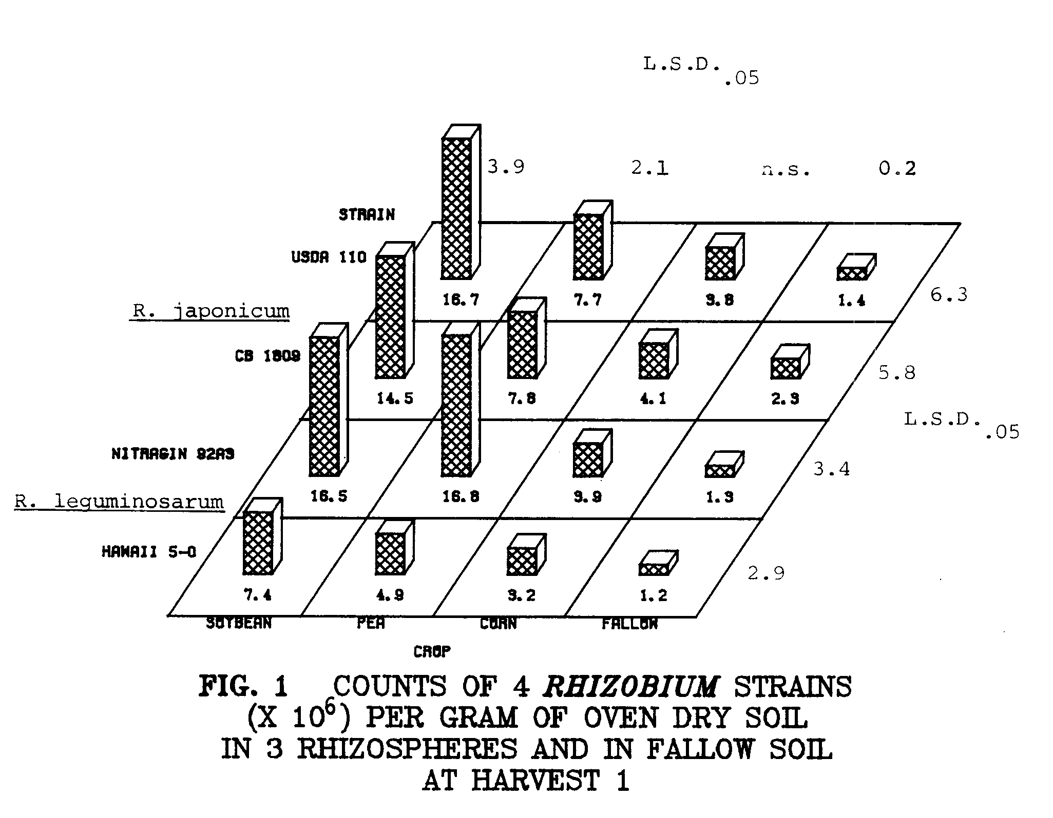
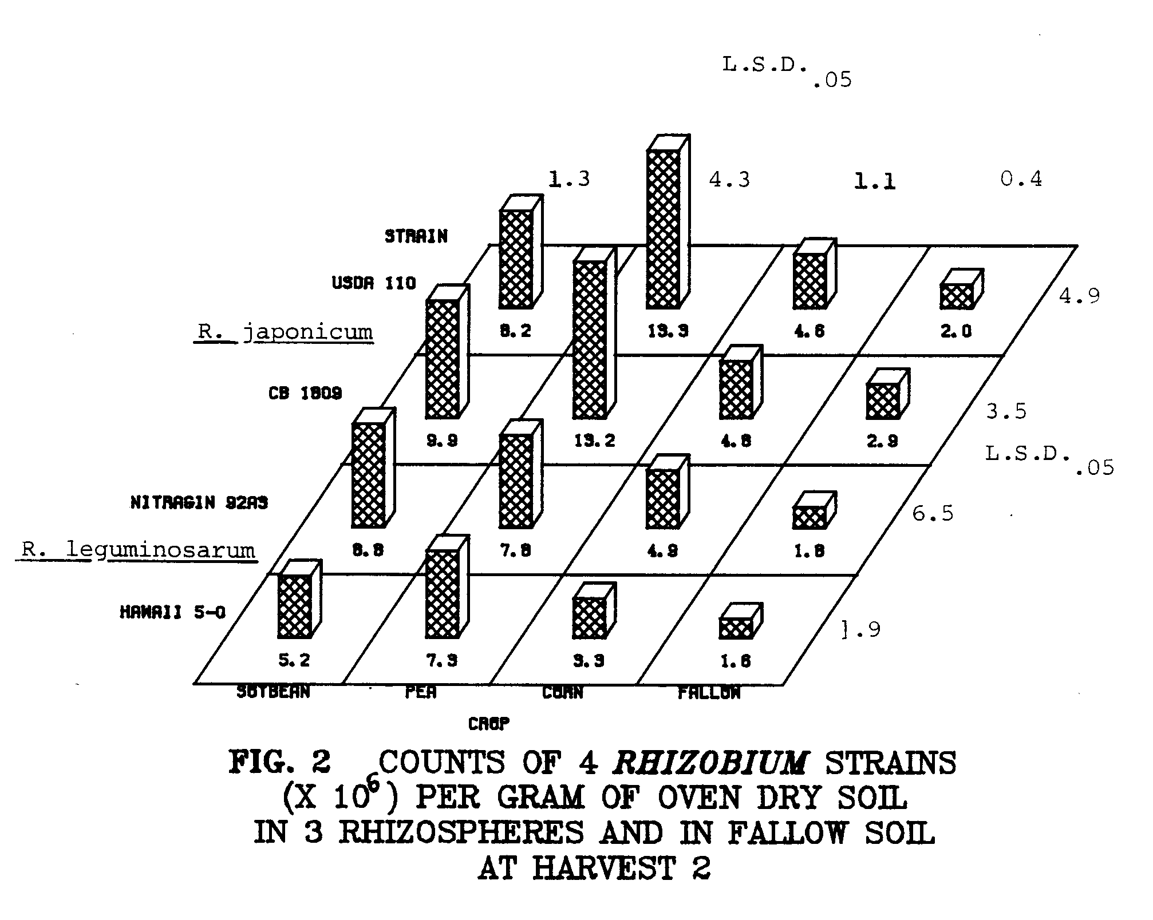
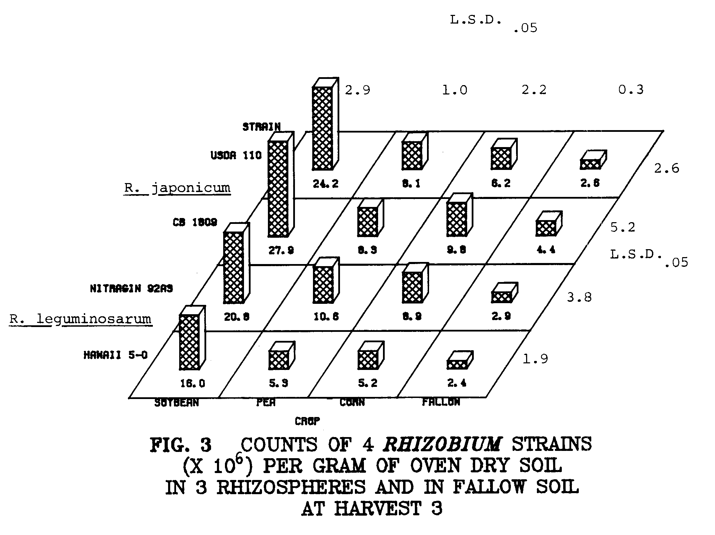
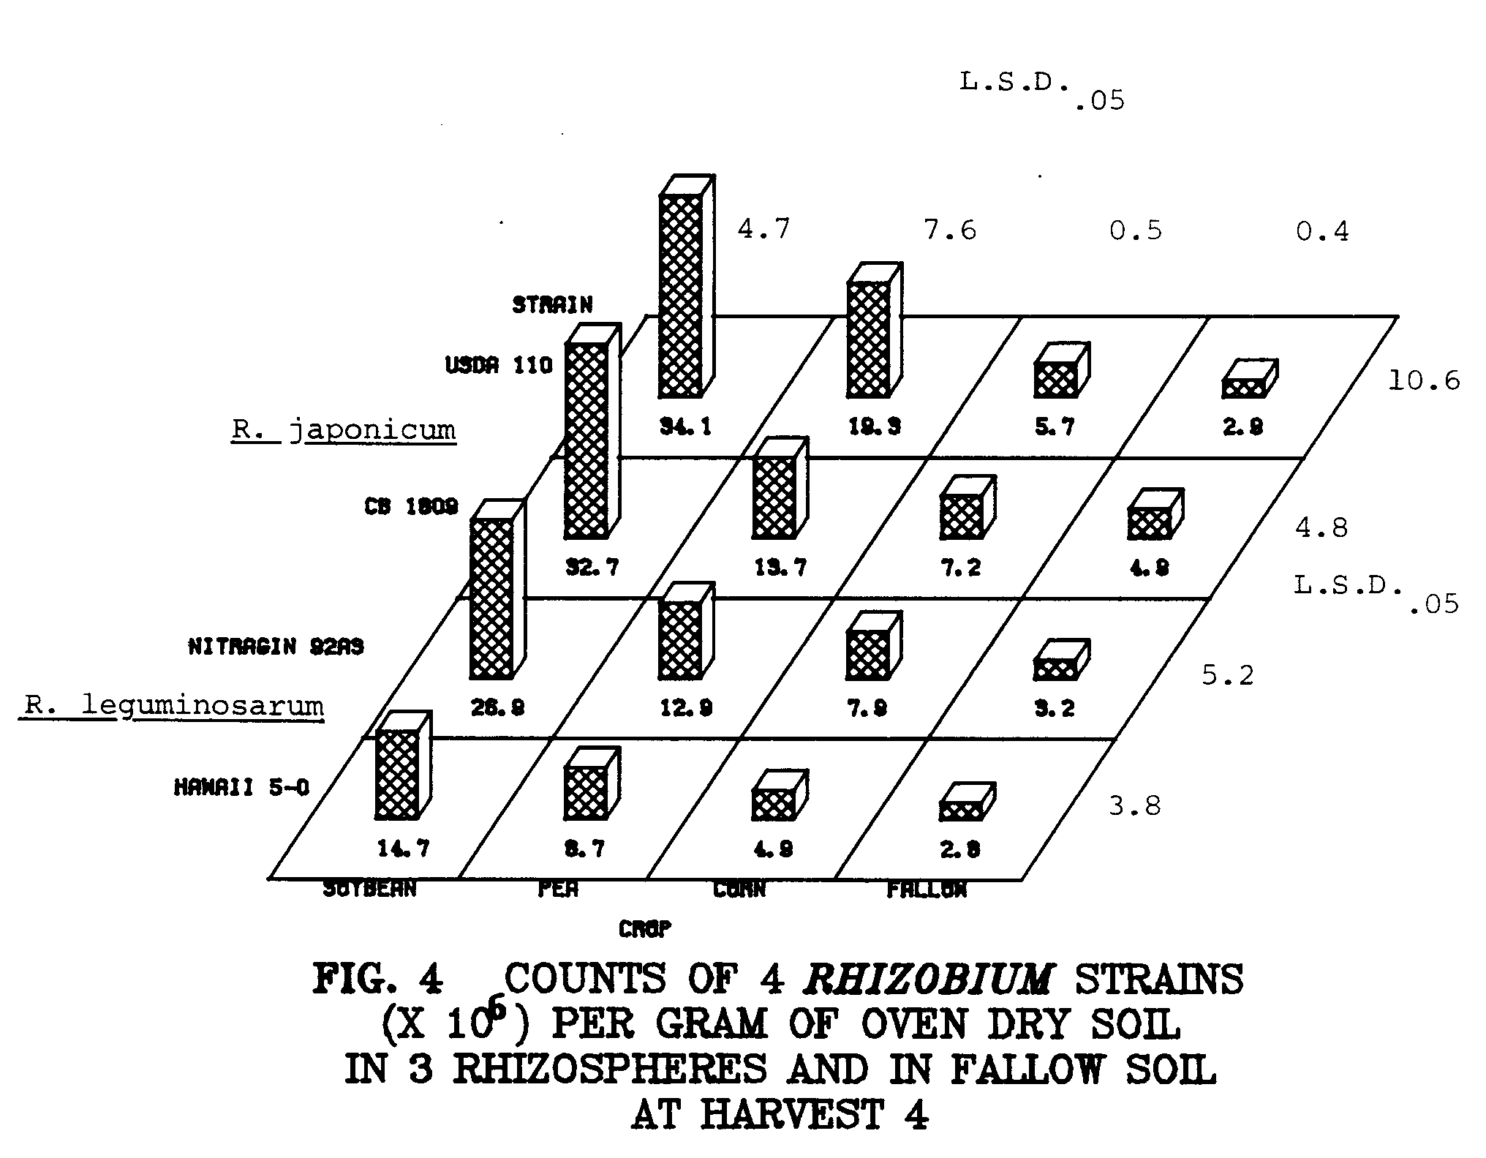
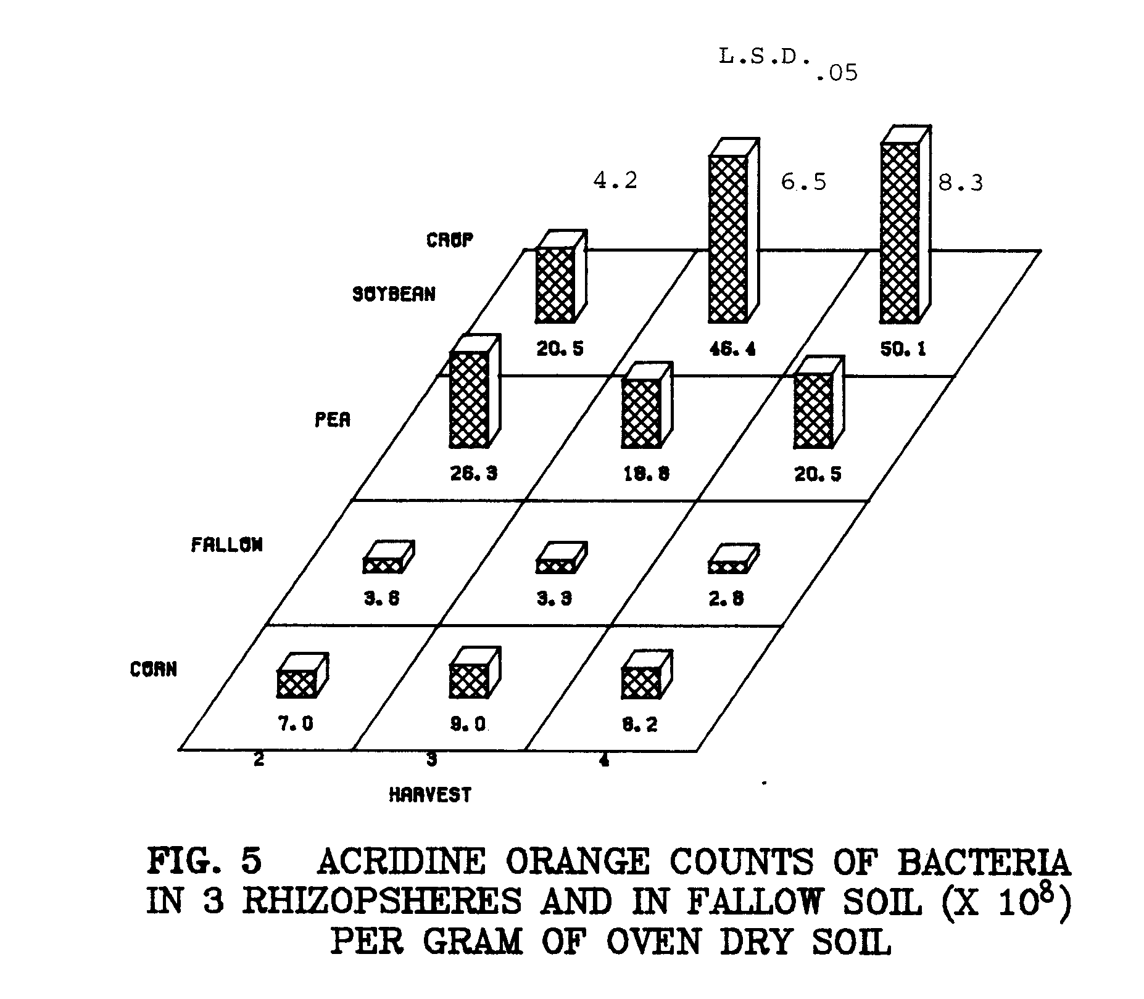
concentrated at the root crown. Mixed infections in nodules occurred at an average of 15% for soybeans and 3.5% for peas. Of interest is the occurrence of nodules on peas containing bacteroids unreactive with either fluorescent antibody (Fig. 7). R. japonicum bacteroids were morphologically similar to broth cultured cells, whereas R. leguminosarum bacteroids were enlarged relative to broth cultured cells, and often branched (Figs. 8 and 9).

FIG. 8 R. JAPONICUM NODULE BACTERIA, STAINED WITH HOMOLOGOUS FLUORESCENT ANTIBODY. CELLS ARE MORPHOLOGICALLY
SIMILAR TO BROTH CULTURED CELLS.
(Scale = 10 μm)

FIG. 9 R. LEGUMINOSARUM NODULE BACTERIA, STAINED WITH HOMOLOGOUS FLUORESCENT ANTIBODY. CELLS ARE ENLARGED RELATIVE TO
BROTH CULTURED CELLS, AND OFTEN BRANCHED.
(Scale = 10 μm)
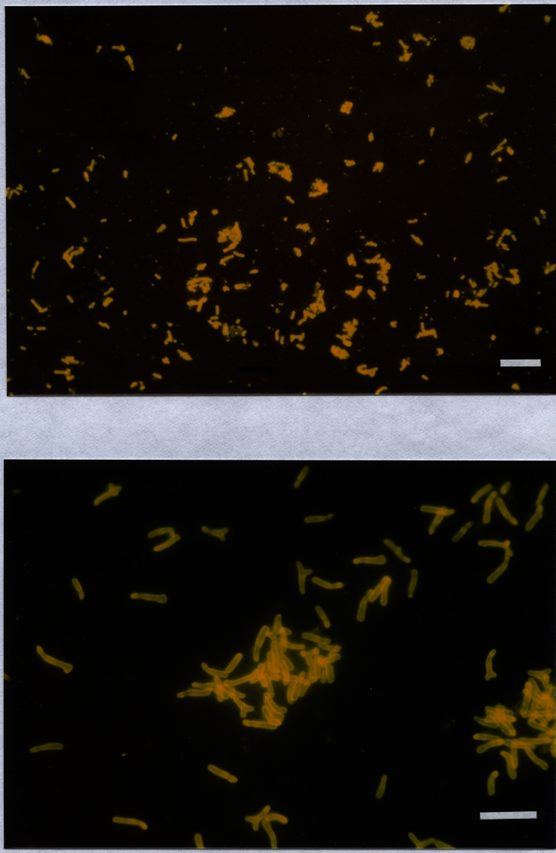
DISCUSSION

One of the factors suggested as an important contributor to specificity in the Rhizobium-legume association is the selective stimulation of the homologous Rhizobium species in the rhizosphere of its homologous host (7,14,25).
However, in this study I found that the growth of R. japonicum was not selectively stimulated in the soybean rhizosphere, and that the growth of R. leguminosarum was not selectively stimulated in the pea rhizosphere. With the exception of harvest 2, rhizosphere numbers of all strains of rhizobia were in the following order: soybeans> peas>corn>non-rhizosphere soil, although differences in rhizosphere populations of the crops are not always significant (Figs. 1 to 4). During growth cycle 2 the plants were subjected to a considerable short-term heat stress, due to the unfortunate failure of the air conditioning unit on the plexiglas house. At harvest 2, rhizosphere populations of the four Rhizobium strains were different than at harvests 1, 3, and 4 (Figs. 1 to 4). Exudation from pea roots might have been enhanced due to the heat stress. Soybean rhizosphere populations of Rhizobium were reduced at harvest 2 relative to the other harvests (Figs. 1 to 4). Apparently exudation from soybean roots was reduced by the heat stress, or an inhibitory substance was exuded. Hawaii 5-0 and USDA 110 were stimulated significantly more in the rhizosphere of peas than in other rhizospheres at harvest 2 (Fig. 2). CB 1809 and Nitragin 92A3 were stimulated to the same extent in the rhizospheres of peas and soybeans at harvest 2 (Fig. 2).
R. japonicum strains CB 1809 and USDA 110 were present in similar numbers in any particular rhizosphere at any harvest (Figs. 1 to 4). These strains apparently had similar rhizosphere colonizing abilities. Hawaii 5-0 was generally seen in significantly lower numbers than the other three strains in all rhizospheres at each of the four harvests (Figs. 1 to 4). Hawaii 5-0 was apparently not as capable of rhizosphere colonization as the other strains in the rhizospheres tested.
In non-rhizosphere soil, CB 1809 was consistently seen in higher numbers than the other strains (Figs. 1 to 4). Because this phenomenon persisted through four harvests, it appeared that CB 1809 was better adapted than the other strains to root-free soil.
Populations of individual Rhizobium strains never rose above about 2 - 3 x 10⁷ per gram of rhizosphere soil, even when soil was continuously cropped with the same plant species. Thus, it seems as though the rhizosphere might have a limited carrying capacity for Rhizobium.
Bacteria enumerated with acridine orange were significantly more prevalent in the soybean rhizosphere than the pea rhizosphere, than the corn rhizosphere at harvests 3 and 4 (Fig. 5). At harvest 2,
total bacterial numbers were higher in the pea rhizosphere than the soybean rhizosphere, probably due to the heat stress mentioned earlier (Fig. 5). This pattern of rhizosphere colonization reflects that seen with rhizobia, with bacteria more prevalent in the soybean rhizosphere, than the pea rhizosphere, than the corn rhizosphere, with the exception of harvest 2 (Figs. 2 to 4). Thus, the stimulation of Rhizobium reflects the stimulation of rhizosphere bacteria in general.
The soybean nodule occupancy data were consistent with soybean rhizosphere counts of the two R. japonicum strains, as neither strain predominated (Figs. 1 to 4 and 6). In the pea rhizosphere, Nitragin 92A3 was seen in numbers averaging twice those of Hawaii 5-0 (Figs. 1 to 4). However, 92A3 was found in nine times as many nodules as Hawaii 5-0 (Fig. 7). Nitragin 92A3 appeared to be a more competent rhizosphere colonizer than Hawaii 5-0, but increased rhizosphere populations of Nitragin 92A3 do not fully explain the competitive advantage of this strain in nodulating peas.
Hawaii 5-0 has been shown to be a very effective competitor in nodulating lentils grown in several tropical soils, including an Inceptisol (S. N. May, M.S. Thesis, 1979, University of Hawaii). Perhaps the competitive ability of strains varies with respect to different host species or cultivars, or with different soil types.
From these data, it appeared as though specific stimulation in the rhizosphere was not a contributor to specificity in the R. japonicum/soybean and R. leguminosarum/pea associations under the conditions of this study. Differences in the growth of rhizobia in host and non-host rhizospheres were manifested at the strain level rather than at the species level. Thus some strains might simply be better rhizosphere colonizers than others, without regard for bacterial or plant species.
LITERATURE CITED

1. Bohlool, B. B. and E. L. Schmidt. 1968. Nonspecific staining: its control in immunofluorescence examination of soil. Science 162:1012-1014.

2. Bohlool, B. B. and E. L. Schmidt. 1973. A fluorescent antibody technique for determination of growth rates of bacteria in soil. Bull. Ecol. Res. Comm. (Stockholm) 17:229-236.

3. Bohlool, B. B. and E. L. Schmidt. 1974. Lectins: a possible basis for specificity in the Rhizobium-legume symbiosis. Science 185:269-271.

4. Bohlool, B. B. and E. L. Schmidt. 1980. The immunofluorescence approach in microbial ecology. pp. 203-241. In M. Alexander (Ed.) Advances in microbial ecology. Vol. 4. Plenum Publishing Corp., New York.

5. Broughton, W. J. 1978. Control of specificity in legumeRhizobium associations. J. Appl. Bacteriol. 45:165-194.

6. Broughton, W. J., Ursula Samrey, and B. Ben Bohlool. 1982. Competition for nodulation of Pisum sativum cv. Afghanistan requires live rhizobia and a plant component. Can. J. Micro. 28: 162-168.

7. Brown, Margaret E., R. M. Jackson, and S. K. Burlingham. 1968. Growth and effects of bacteria introduced into soil. In T. R. G. Gray and D. Parkinson (Eds.) The ecology of soil bacteria. Liverpool Univ. Press, Liverpool. pp. 531-551.

8. Van Egeraat, A. W. S. M. 1975. The growth of Rhizobium leguminosarum on the root surface and in the rhizosphere in relation to root exudates. Plant and Soil 42:367-379.

9. Graham, Terrence L. 1981. Recognition in Rhizobium-legume symbioses. In Kenneth L. Giles and Alan G. Atherly (Eds.) Biology of the rhizobiaceae. Academic Press, Inc., New York.

10. Hoagland, D. R. and D. I. Arnon. 1938. The water culture method for growing plants without soil. Calif. A9, Exp. Sta. Circular 347.

11. Kingsley, Mark T. and B. Ben Bohlool. 1981. Release of Rhizobium spp. from tropical soils and recovery for
immunofluorescence enumeration. Appl. Environ. Micro. 42:241-248.

12. Krasil’nikov, N. A. 1958. Soil mincroorganisms and higher plants. Acad. Sci. USSR Moscow. English ed. National Science Foundation.
13. MacGregor, A. N. and M. Alexander. 1972. Comparison of nodulating and non-nodulating strains of Rhizobium trifolii. Plant and Soil 36:129-139.

14. Nutman, P. S. 1965. The relation between nodule bacteria and the legume host in the rhizosphere and in the process of infection. In K. F. Baker and W. C. Snyder (Eds.) The ecology of soil-borne plant pathogens. pp. 231-247. U niv. Calif. Press, Berkeley.

15. Peters, R. J. and M. Alexander. 1966. Effect of legume exudates on the root nodule bacteria. Soil Sci. 102:380-387.

16. Purchase, H. F. and P. S. Nutman. 1957. Studies on the physiology of nodule formation. VI. The influence of bacterial numbers in the rhizosphere on nodule formation. Ann. Bot. Cond., N. S. 21:439.

17. Rovira, A. D. and J. R. Harris. 1961. Plant root excretions in relation to the rhizosphere effect. V. The excretion of B-group vitamins. Plant and Soil 14:199.

18. Schmidt, E. L., R. 0. Bankole, and B. B. Bohlool. 1968. Fluorescent antibody approach to study of rhizobia in soil. J. Bact. 95:1987-1992.

19. Schmidt, E. L. 1974. Quantitative autoecological study of microorganisms in soil by immunofluorescence. Soil Science 118:141-149.

20. Schmidt, E. L. 1978. Ecology of the legume root nodule bacteria. pp. 269-303. In Y. R. Dommergues and S. V. Krupa (Eds.) Interactions between non-pathogenic soil microorganisms and plants. Elsevier Scientific Publishing Co., Amsterdam.

21. Schmidt, E. L. 1979. Initiation of plant root-microbe
interactions. Ann. Rev. Microbiol. 33:355-376.

22. Schmidt, E. L. and B. B. Bohlool. 1981. The role of lectins in symbiotic plant-microbe interactions. In W. Tanner and F. A. Loewus (Eds.) Encyclopedia of plant physiology, New Series Vol. 13 B. Plant Carbohydrates II. Springer-Verlag, Berlin, Heidelberg.

23. Tsien, H. C., P. S. Cain, and E. L. Schmidt. 1977. Viability of Rhizobium bacteroids. Appl. Environ. Micro. 34:854-856.

24. Vincent, J. M. 1970. A manual for the practical study of root nodule bacteria. International Biological Programme Handbook no. 15. Blackwell Scientific Publications, Oxford, England.

25. Vincent, J. M. 1974. Root nodule symbiosis with Rhizobium. pp. 265-341. In A. Quispel (Ed.) The biology of nitrogen fixation. North Holland Publishing Co., Amsterdam.

CHAPTER 3
POPULATIONS OF RHIZOBIUM IN THE RHIZOSPHERES OF HOST
AND NON-HOST PLANTS DURING A 35-DAY GROWTH CYCLE
ABSTRACT

The growth of two R. japonicum strains (USDA 110 and CB 1809) and two R. leguminosarum strains (Hawaii 5-0 and Nitragin 92A3) was followed in the rhizospheres of soybean, pea, and corn plants growing in non-sterile soil. Rhizosphere soil was sampled at weekly intervals over a 35-day growth period. Rhizosphere numbers of each strain were determined by membrane filter immunofluorescence, using strain-specific fluorescent antibodies. Numbers of the four strains were highest in the soybean rhizosphere at 1 week, averaging 2.0 x 10⁷ per gram of soil. Numbers of the four strains peaked in the pea rhizosphere at 4 weeks, averaging 1.5 x 10⁷ per gram of soil. At 1, 2, and 3 weeks, numbers per gram of soil of all strains were significantly higher in the soybean rhizosphere than in the pea rhizosphere, than in the corn rhizosphere, than in fallow soil. At week 4, pea rhizosphere numbers per gram of soil of all strains significantly surpassed soybeans rhizosphere numbers (1.5 x 10⁷ and 1.2 x 10⁷, respectively). At 5 weeks, rhizosphere numbers of all strains were in the following order: pea>corn>soybean>fallow soil. Differences between Rhizobium numbers in the rhizospheres of the three crops were more difficult to detect on a root surface area basis. Numbers of all strains declined at 5 weeks per gram of soil and per square cm of root. No specific stimulation of rhizobia by their legume hosts was observed. Strains Nitragin 92A3, CB 1809, and USDA 110 were more successful rhizosphere colonizers than Hawaii 5-0. Acridine orange total counts of bacteria were highest on the basis of soil weight in the rhizospheres of the three crops at 1 week, and following a decline at 2 weeks, remained relatively constant for the remainder of the experiment. Acridine orange total counts on the basis of root surface area were variable, and patterns were not evident. Percentages of soybean nodules occupied by the two R. japonicum strains reflected the rhizosphere populations of the strains, as neither predominated. Mixed infections were observed at an average of 7%. The majority of large nodules on peas contained Nitragin 92A3, and a lesser number, Hawaii 5-0. Sixteen percent of large pea nodules contained R. leguminosarum bacteroids unreactive with fluorescent antibodies prepared against the two inoculant strains. In small pea nodules, either one or both of the two inoculant strains were present in most nodules at harvests 3 and 4. An unidentified strain or strains occupied 74% of the small pea nodules at harvest 5. Mixed infections in pea nodules varied from 4 to 10% in small and large nodules, respectively. I found no evidence to support the theory of specific stimulation of rhizobia by their homologous legume hosts in the R. japonicum/soybean and R. leguminosarum/pea associations.
INTRODUCTION

Rhizobia are distinguished from other soil bacteria by their unique ability to form nitrogen-fixing nodules on the roots of many leguminous plants. Rhizobia are specific with respect to the hosts they nodulate. Only certain species of Rhizobium are able to infect and nodulate the roots of particular legumes. Although the relationship between rhizobia and their host legumes has been studied in great detail, the basis for this specificity is not completely clear (3,16).
Several possible mechanisms have been proposed to account for specificity, involving both plant and bacterial components (3). Cellular recognition between host and bacterium is considered by some as a mechanism for specificity. Plant proteins called lectins are thought to interact specifically with rhizobia at the root surface (6,17).
Another mechanism proposed as a possible contributor to specificity in the Rhizobium-legume symbiosis is the preferential growth of the appropriate Rhizobium in the rhizosphere of its homologous host plant over and above that of other non-homologous rhizobia, and over other soil microorganisms (3,10,19).
Most studies of stimulation in the legume rhizosphere have been carried out in aseptic systems, from which rhizobia can be conveniently plated and counted (5,9,11). Extrapolation from aseptic conditions to non-sterile field soil, in which the full range of microbial interactions would be occurring, is unrealistic, and probably erroneous.
In a study described earlier (Chapter 2) rhizosphere numbers of four strains of Rhizobium were determined in homologous and nonhomologous legume rhizospheres over four successive 35-day growth cycles. Rhizobium populations were assessed on the basis of soil weight by membrane filter immunofluorescence with strain-specific fluorescent antibodies (1,8,15). Specific stimulation of homologous rhizobia by their legume hosts was not observed, and rhizosphere colonization by rhizobia reflected more strain differences than species differences. It is possible however, that specific stimulation could have occurred earlier in the growth cycle, possibly just prior to the onset of nodulation. If this was the case, an experiment in which rhizosphere sampling and enumeration was done at 35 days would probably overlook specific stimulation.
Rovira (14) suggested that microbial densities in the rhizosphere on a unit soil weight basis be used with caution, since rhizosphere soil weights are affected by plant species, soil moisture, soil structure, and handling of the root during recovery of rhizosphere soil. He suggested that rhizosphere numbers be expressed on the basis of root weight. Reyes and Schmidt (13) suggested that an even more conservative method would be to express microbial densities on the basis of root surface area, as roots of various plant species vary in size, type and growth characteristics. They conducted a series of experiments (12,13) to determine if stimulation of R. japonicum strain 123 in the soybean rhizosphere is a possible contributor to this strain’s extraordinary success in nodulating soybeans in soils of the Midwest (7). They were unable to detect any specific stimulation of strain 123 in the soybean rhizosphere.
What follows is the description of an experiment in which membrane filter immunofluorescence was used to assess the population dynamics of homologous and non-homologous rhizobia in the rhizospheres of host and non-host plants over one 35-day growth cycle, with harvests at weekly intervals. Immunofluorescence counts of rhizobia and acridine orange counts of total bacteria are presented on the basis of root surface area as well as rhizosphere soil weight.
MATERIALS AND METHODS

Rhizobium Strains and Inoculum Preparation
Kula loam soil, an Inceptisol, was prepared as described previously (Chapter 2). R. japonicum strains CB 1809 and USDA 110, and R. leguminosarum strains Hawaii 5-0 and Nitragin 92A3 were obtained from the collection of B. B. Bohlool of the University of Hawaii. Strains were maintained on yeast-extract mannitol agar slants (18) with 1.0 g of yeast extract (Difco Laboratories, Detroit, Michigan) substituted for yeast-water. Inoculum was prepared as previously described (Chapter 2). Initial levels of the four Rhizobium strains per gram of moist soil were as follows as determined by membrane filter immunofluorescence: R. japonicum CB 1809, 4.7 x 10⁵, and USDA 110 4.6 x 10⁵, R. leguminosarum Hawaii 5-0, 3.8 x 10⁵ and Nitragin 92A3 4.3 x 10⁵.

Pots and Planting
Pots were 25 cm in diameter and 20 cm high and were painted with a heavy coat of flat white paint. A watering device was placed into each pot to provide water to the plants in the cores as evenly as possible (Diagram 1). The pots were than each filled with 5.5 kg of moist Kula soil. Cores of p.v.c. pipe of various sizes were then driven into the soil in the pattern outlined in Diagram 2. The soil inside of the cores was loosened slightly with a stout wire. The soil was adjusted to about -1/3 bars of moisture tension with deionized water. Three-day-old soybean, pea, and corn seeds (pre-germinated as described before) were planted, one per core. Following planting, the soil surface was covered with rinsed white aquarium gravel, to prevent undue soil heating and to inhibit the growth of algae.
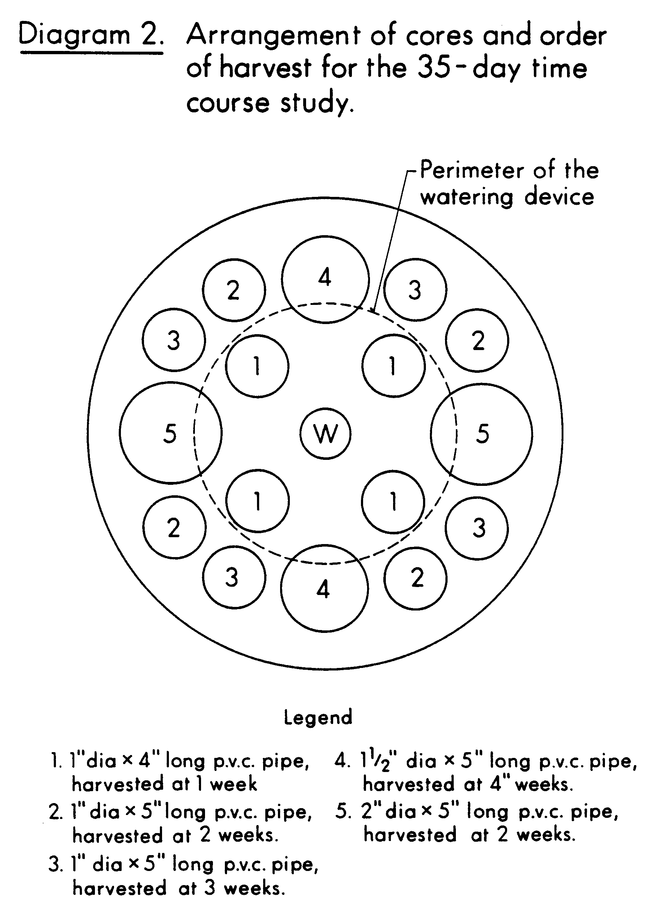
Plant Growth Conditions
The soil moisture tension was maintained at about -1/3 bars throughout the experiment by watering to a constant weight with deionized water. Water was poured into the central upright tube of the watering device. In this manner, water was supplied to the roots in the cores as evenly as possible from the perimeter of the base of the device, rather than from a single central location. The experiment was set up as a randomized complete block with three replications and carried out under natural lighting in a greenhouse.

Harvest and Sample Preparation
At harvests 1, 2, and 3, four cores were removed from each pot as outlined in Diagram 2. At harvests 4 and 5, two cores were removed from each pot (Diagram 2). Root systems were separated from the cores by gently tapping the cores on the inside of a metal pan. Soil that adhered to the root system after gentle shaking was considered to be rhizosphere soil. All other soil was returned to the cores in the pots and gently compacted. Non-rhizosphere soil was removed from the cores as above, pooled, mixed, and a 10-gram sample taken. The remainder was placed back into the cores as described above.
Bacteria were released from root surfaces and rhizosphere soil particles as previously described (Chapter 2). At harvest 1, 50 ml of the gelatin-ammonium phosphate mixture (8) was used for extractions rather than 100 ml, because of the small amount of rhizosphere soil present.

Root Surface Area Estimation
Root surface area was estimated by the method of Carlson (4), as modified by Reyes and Schmidt (13) for greenhouse-grown soybeans.
Enumeration of Bacteria
Membrane filter counts were performed as described by Kingsley and Bohlool (8). Duplicate filters were counted for each strain from each pot, for a total of 96 filters per harvest. Acridine orange total counts were made at each harvest as previously described. Three filters were counted per pot, for a total of 36 per harvest.

Nodule Typing
All nodules were removed, squashed, smeared on microscope slides, and serologically typed with fluorescent antibodies as previously described (Chapter 2).
RESULTS

Rhizosphere numbers of each of the four inoculant strains are presented at weekly intervals on the basis of soil weight in Figures 1 to 5. Numbers of all strains per gram of rhizosphere soil are in the following order at 1, 2, and 3 weeks: soybean>pea>corn>non-rhizosphere soil (Figs. 1 to 3). At 4 weeks rhizobia per gram of soil had declined in the soybean rhizosphere, but increased in that of peas, significantly surpassing soybean rhizosphere numbers (Fig. 4). Rhizobium numbers per gram of soil of all strains were higher in the soybean rhizosphere than that of corn at 4 weeks, with the exception of
Hawaii 5-0 (Fig. 4). At 5 weeks, numbers of rhizobia per gram of soil were in the following order: pea>corn>soybean>non-rhizosphere soil.
Rhizosphere numbers of each of the four strains are presented at weekly intervals on the basis of root surface area in Figures 6 to 10. Differences in rhizosphere populations of Rhizobium between the crops were more difficult to detect on the basis of root surface area, owing to the variability in the estimations of root surface area (Figs. 6 to 10).
Rhizosphere bacteria enumerated using acridine orange fluorescence microscopy were in the following order: soybean>pea>corn>nonrhizosphere soil. However, the variability of the acridine orange total counts was high, and differences between crops and non-rhizosphere soil are often not significant (Fig. 11). Differences between rhizosphere populations of bacteria per square cm of root between crops were even more difficult to detect, with the only significant differences at 5 weeks (Fig. 12).
Soybean nodules contained the two inoculant R. japonicum strains as outlined in Figure 13. Mixed infections were observed at an average
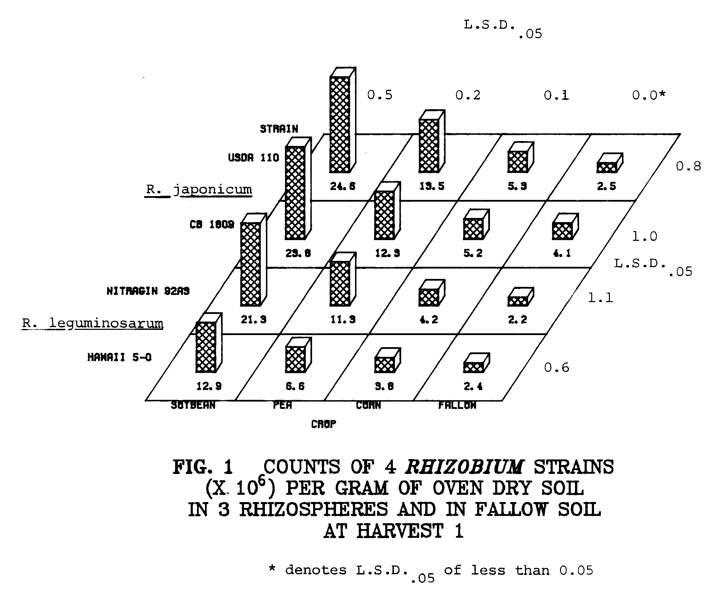
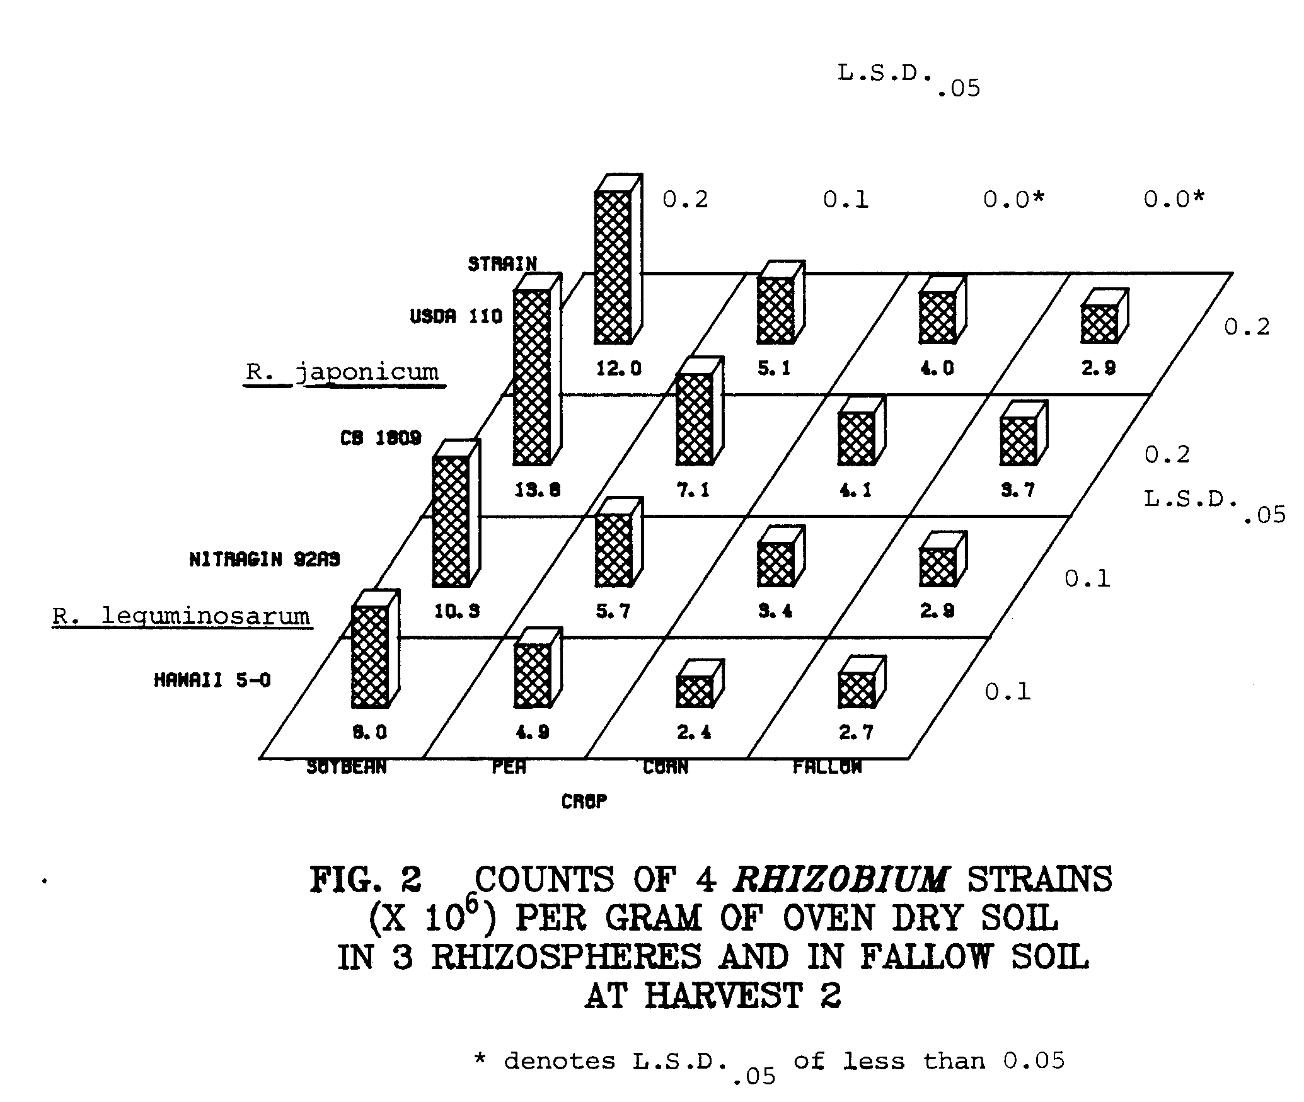
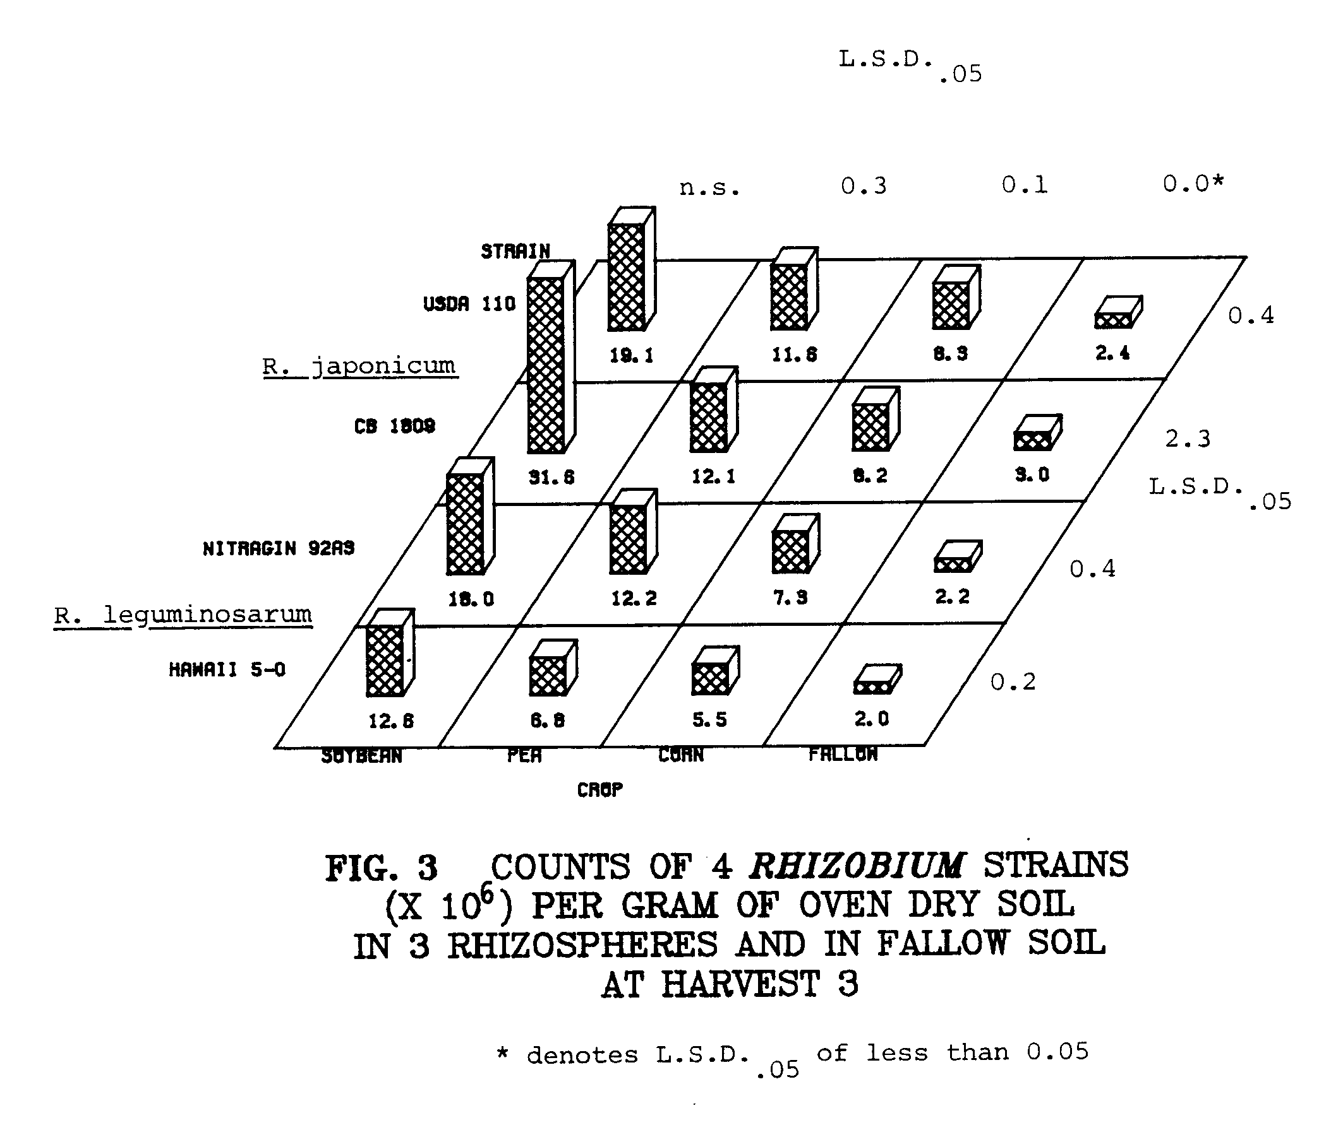
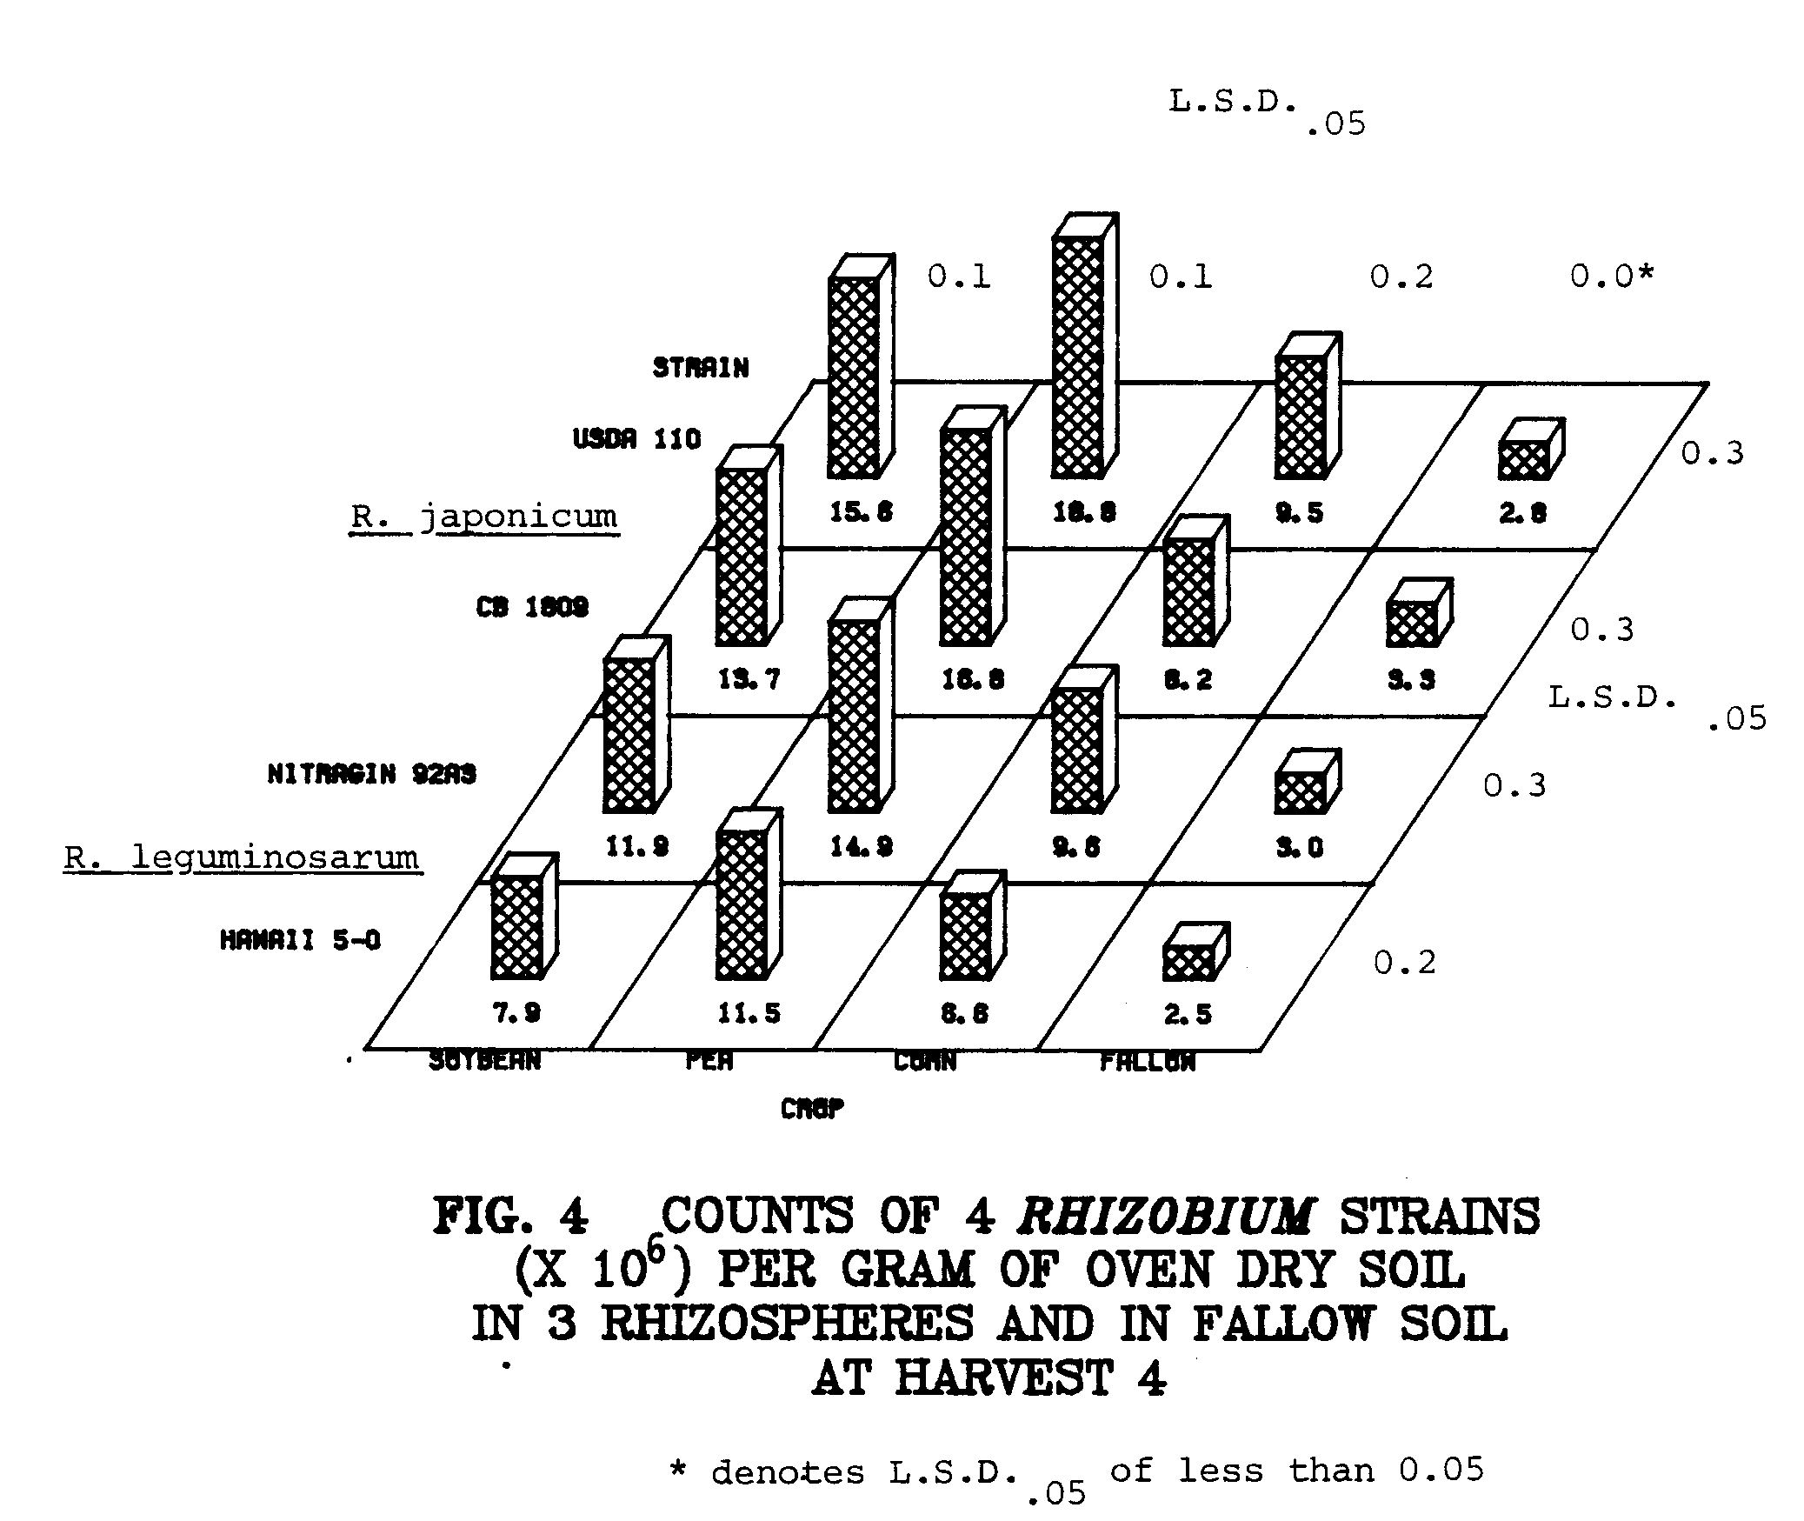
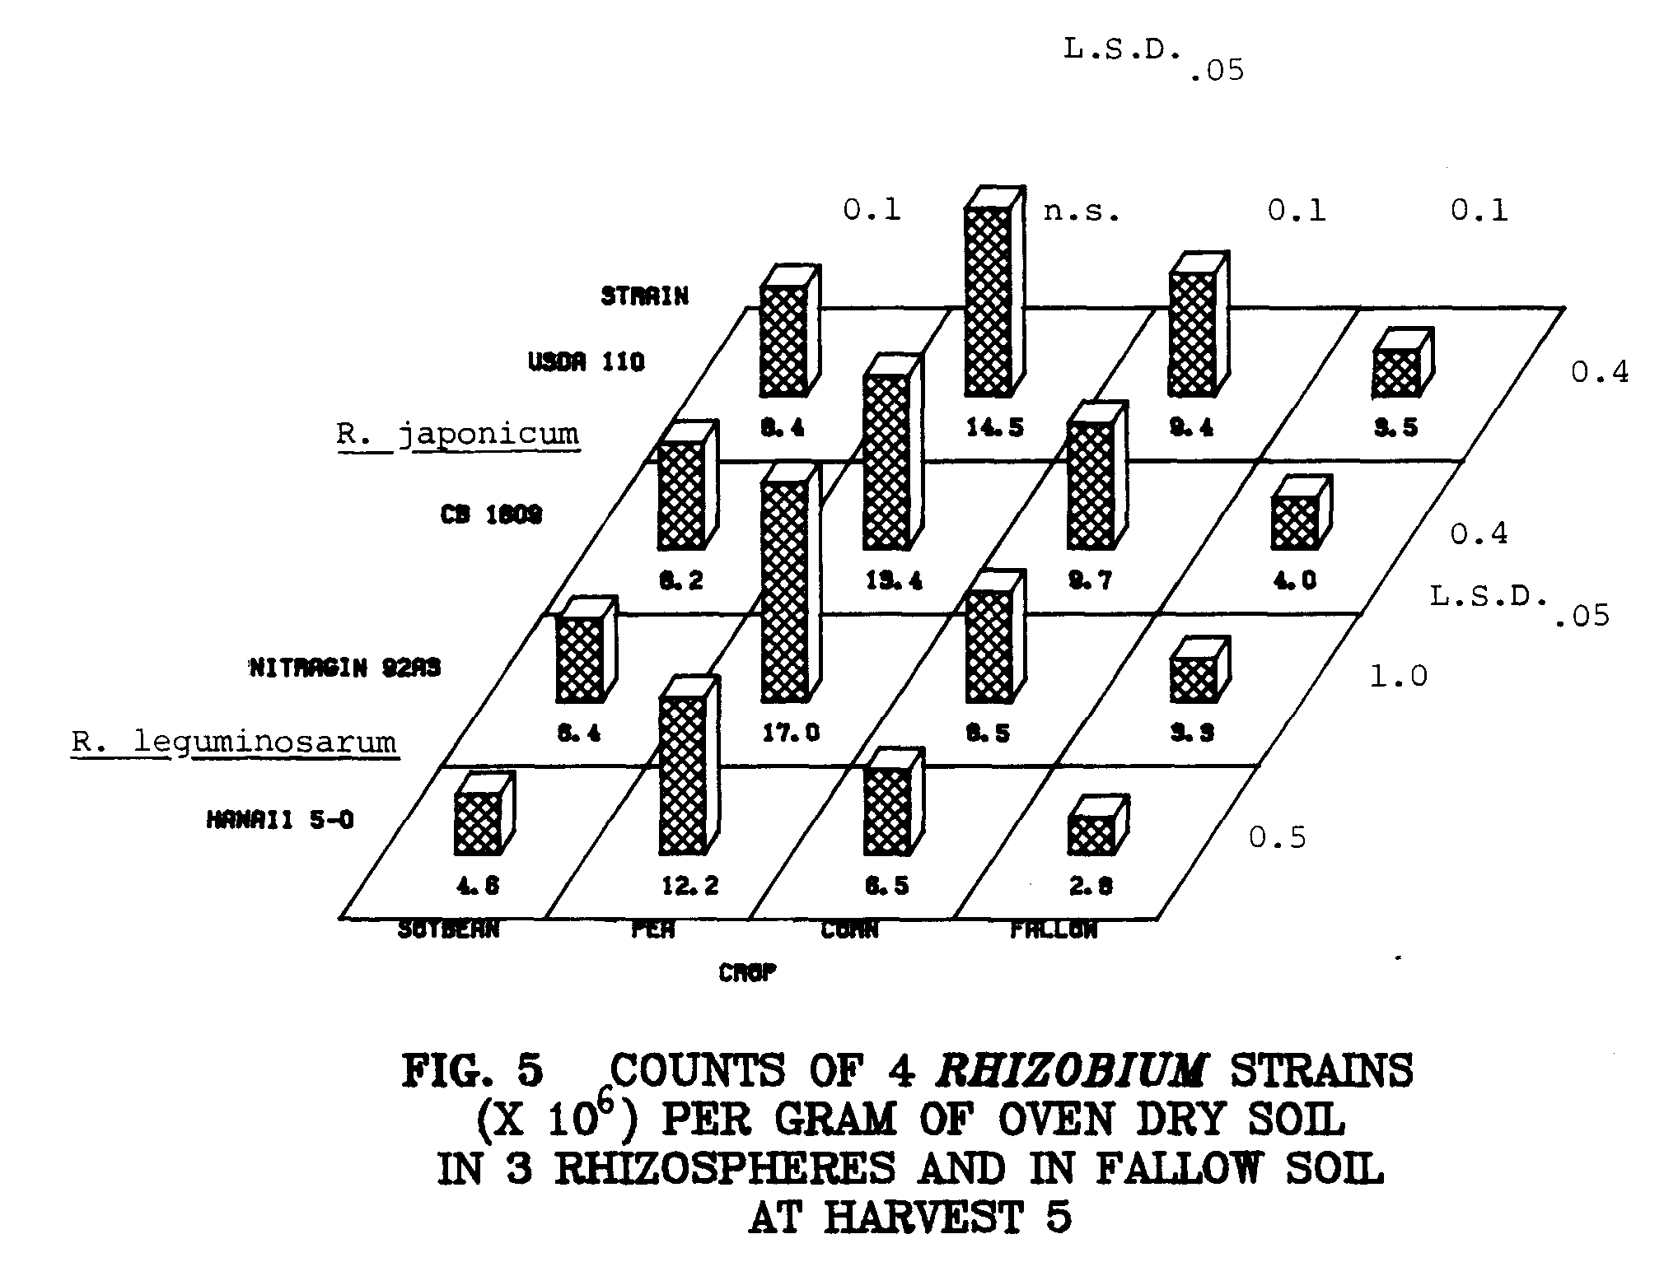
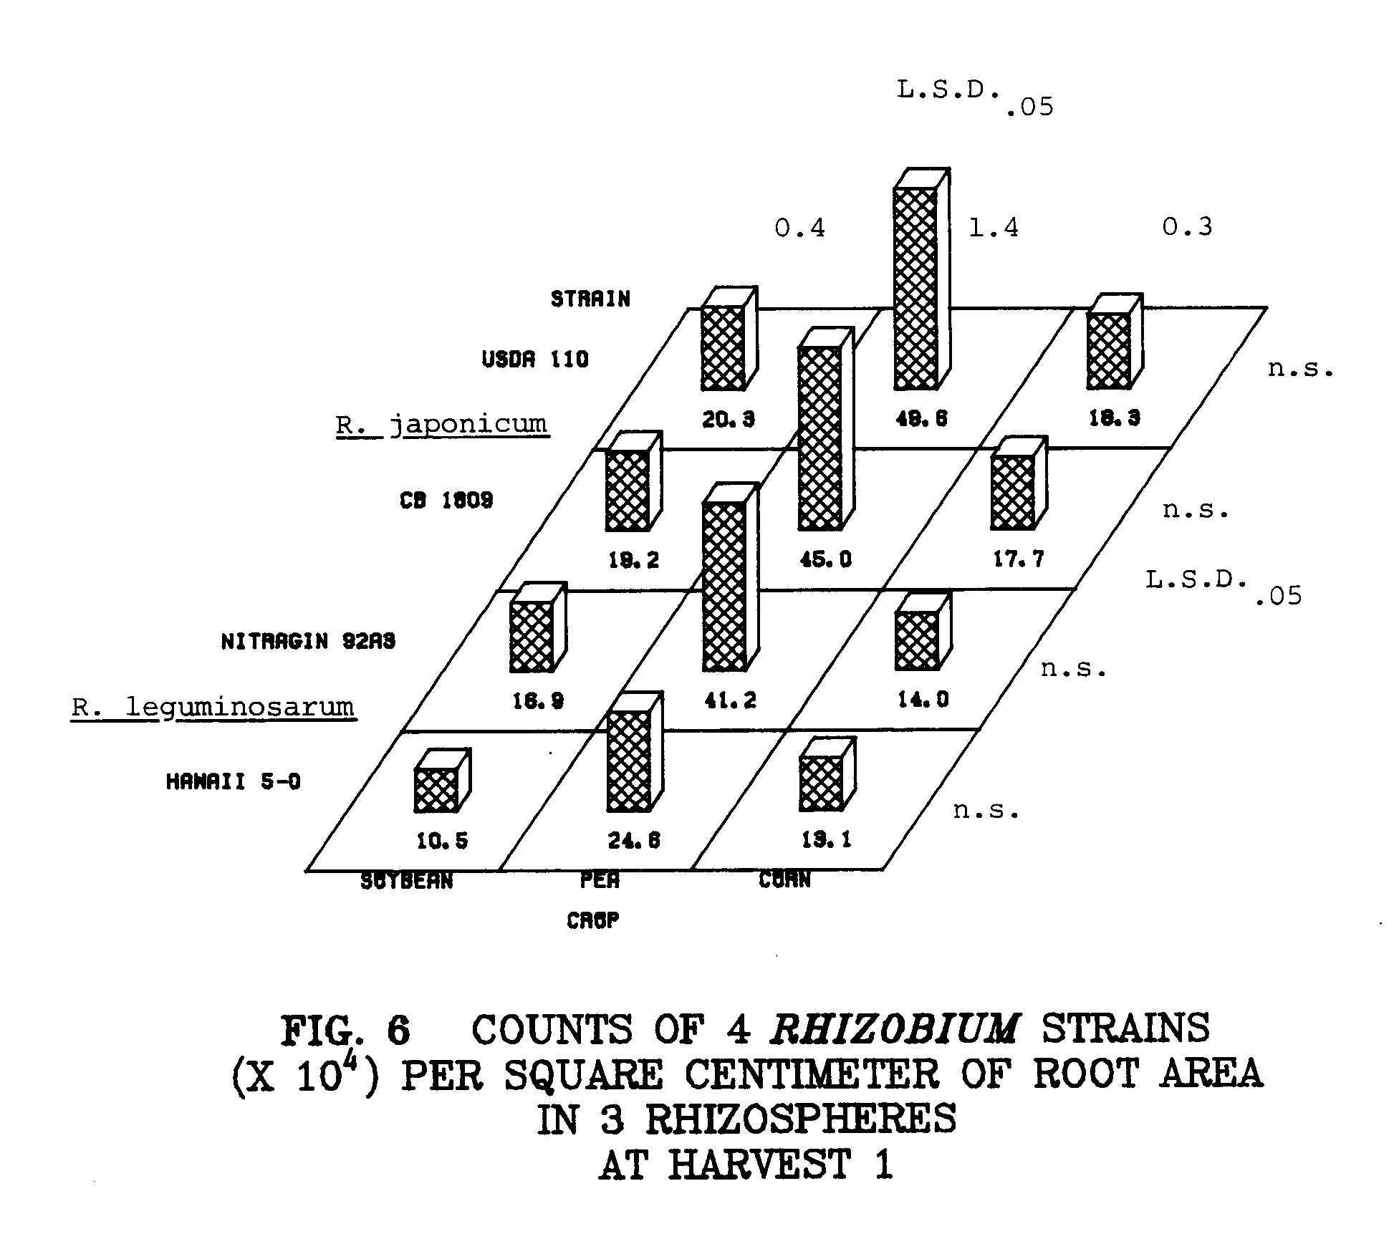
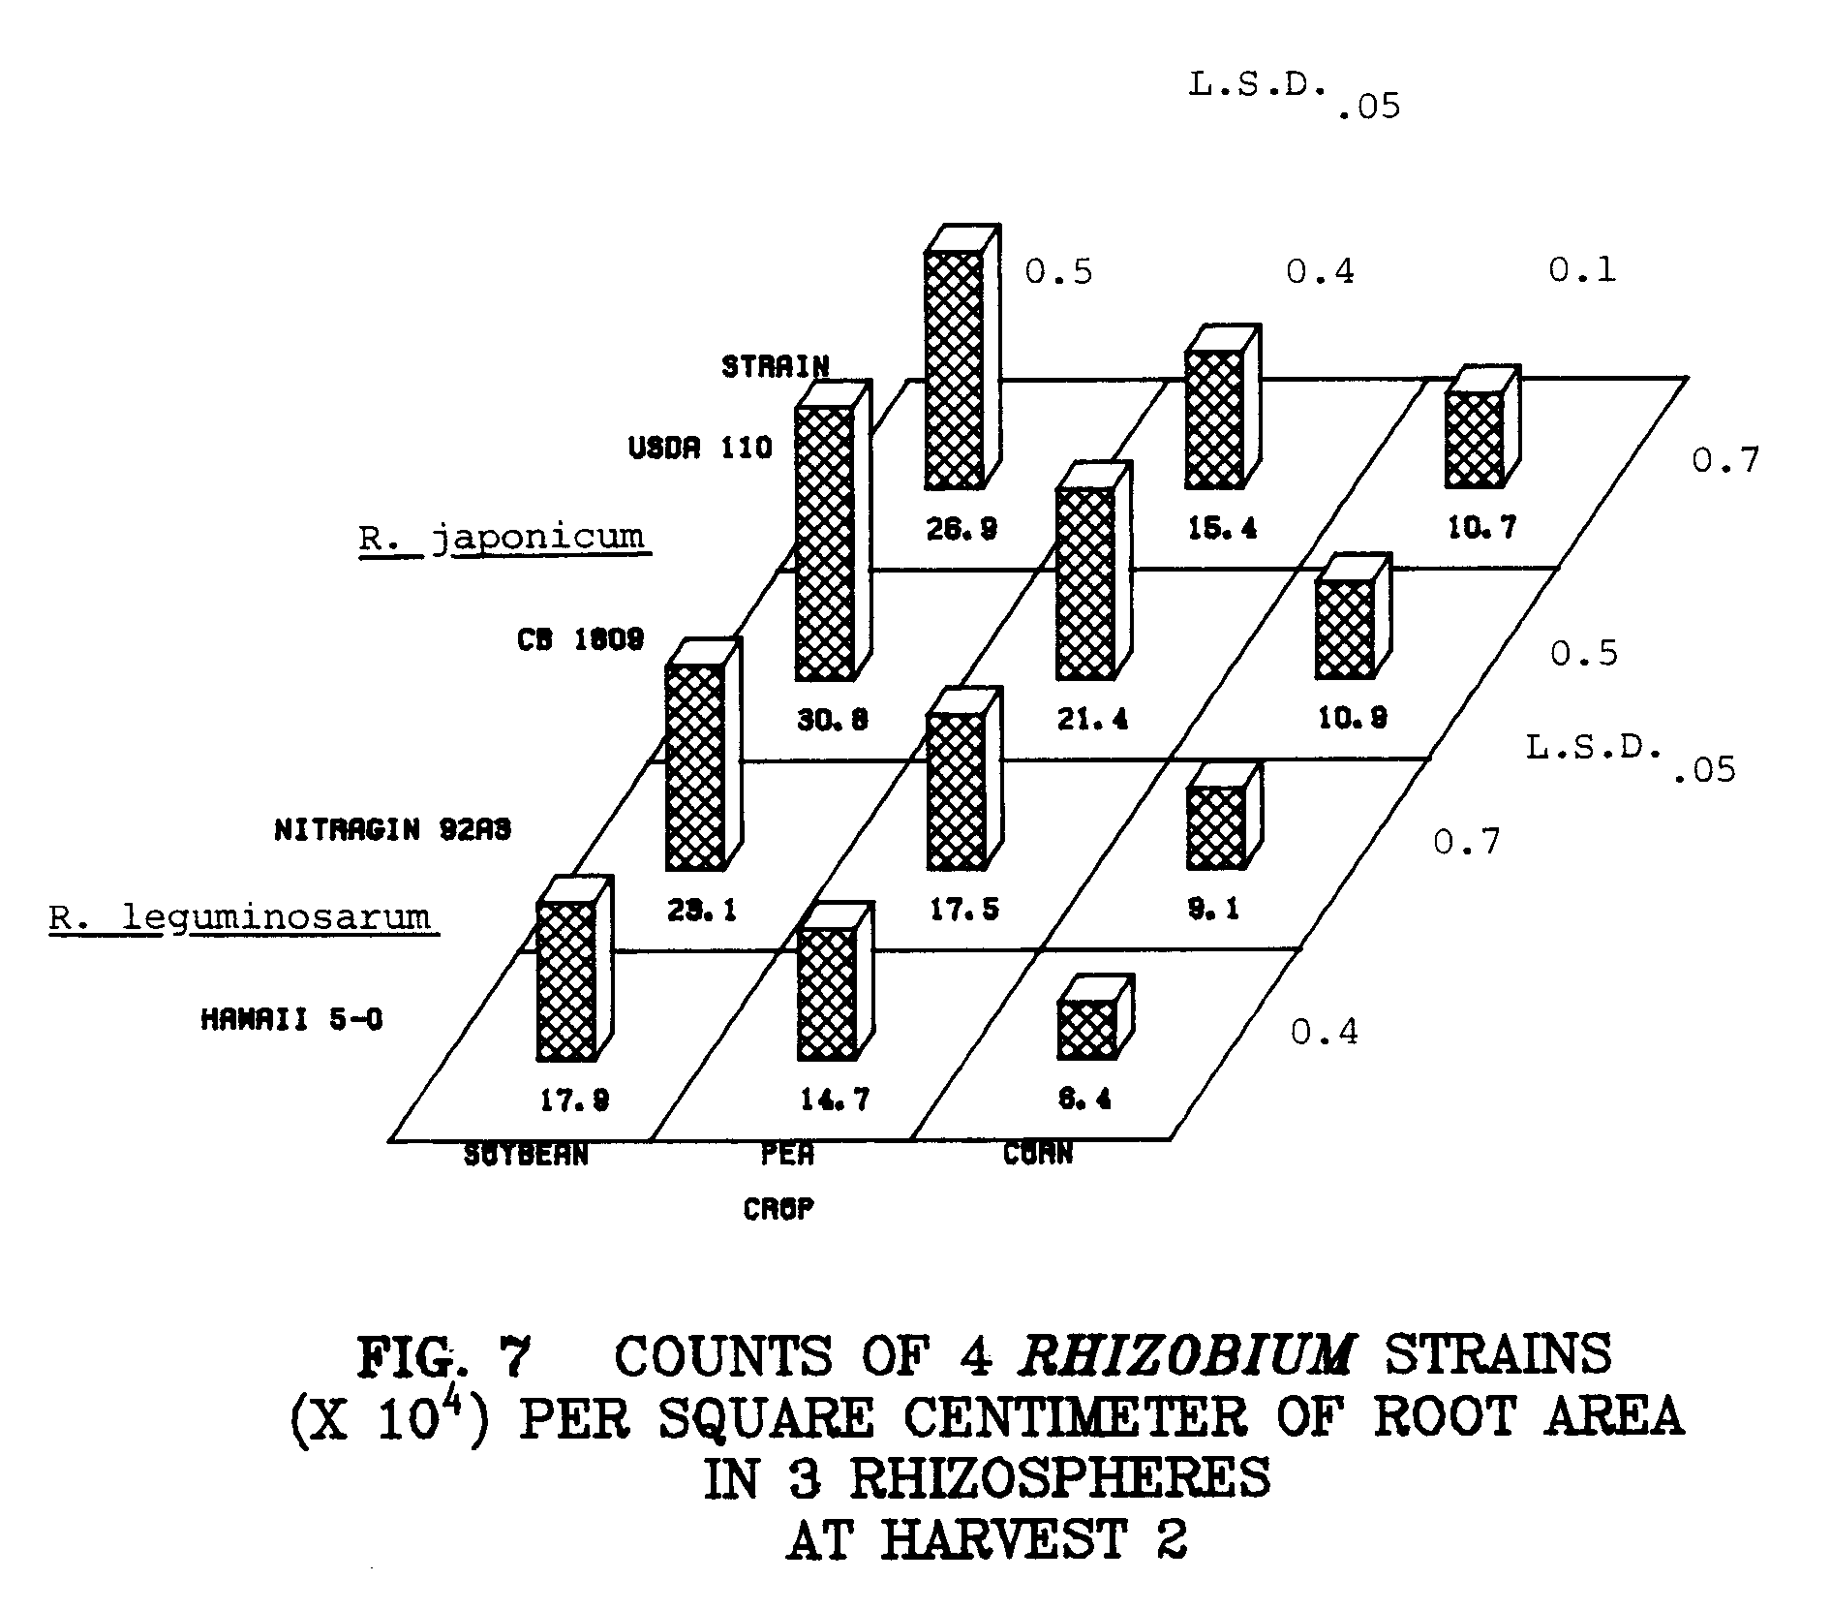
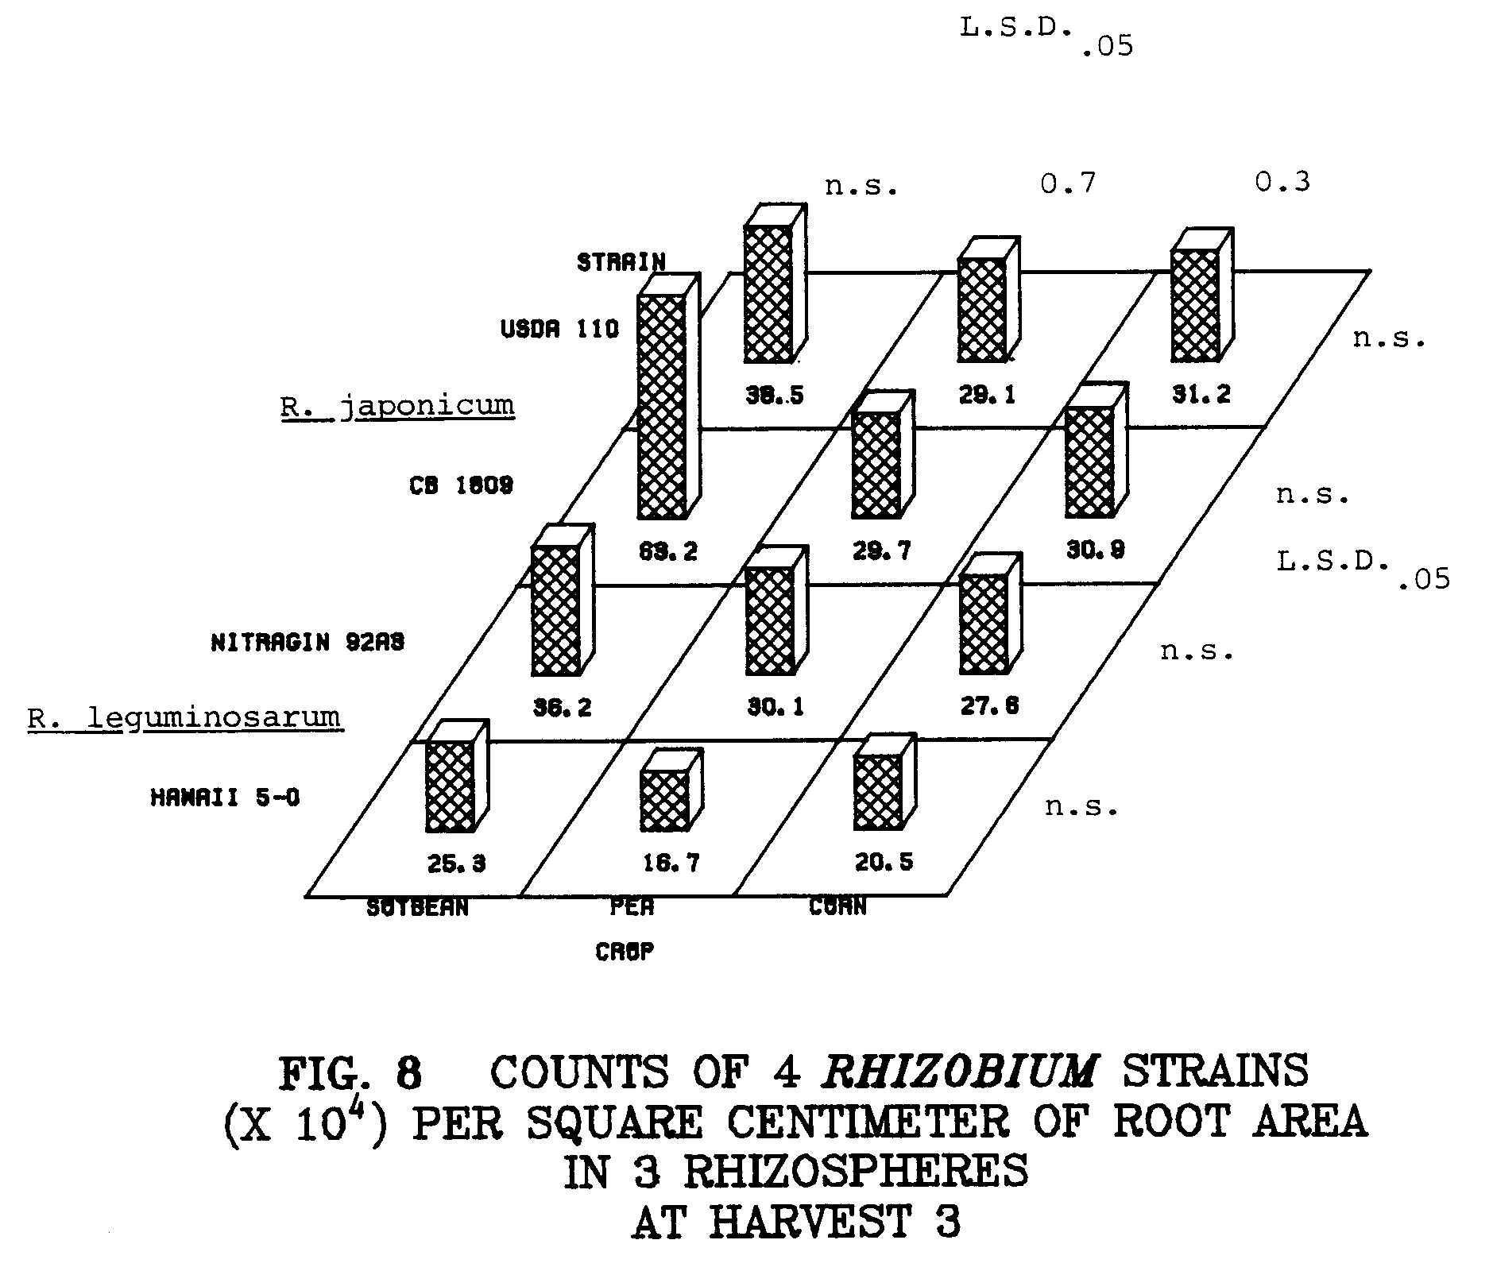
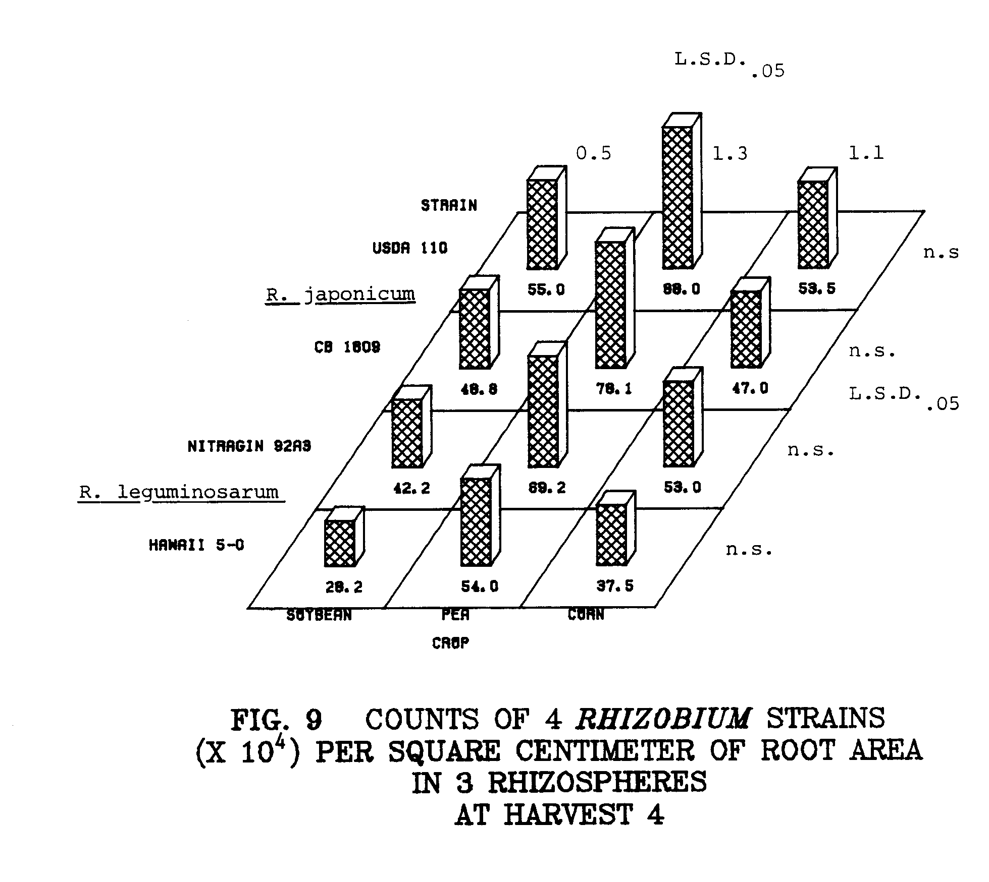
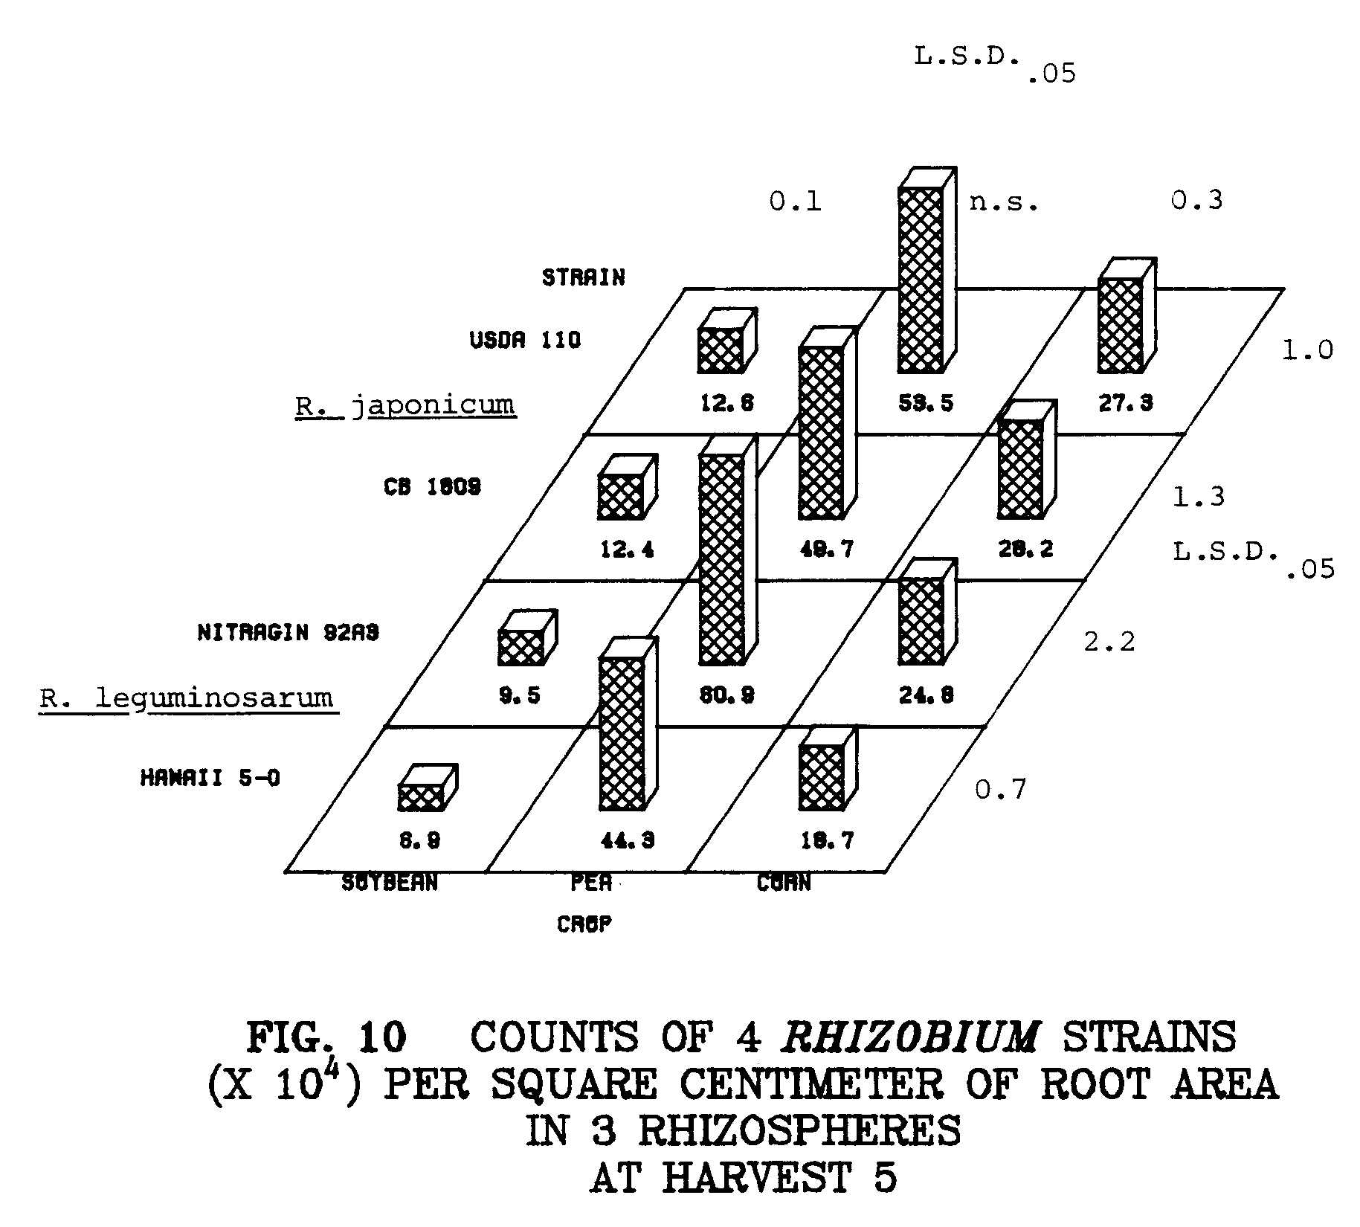
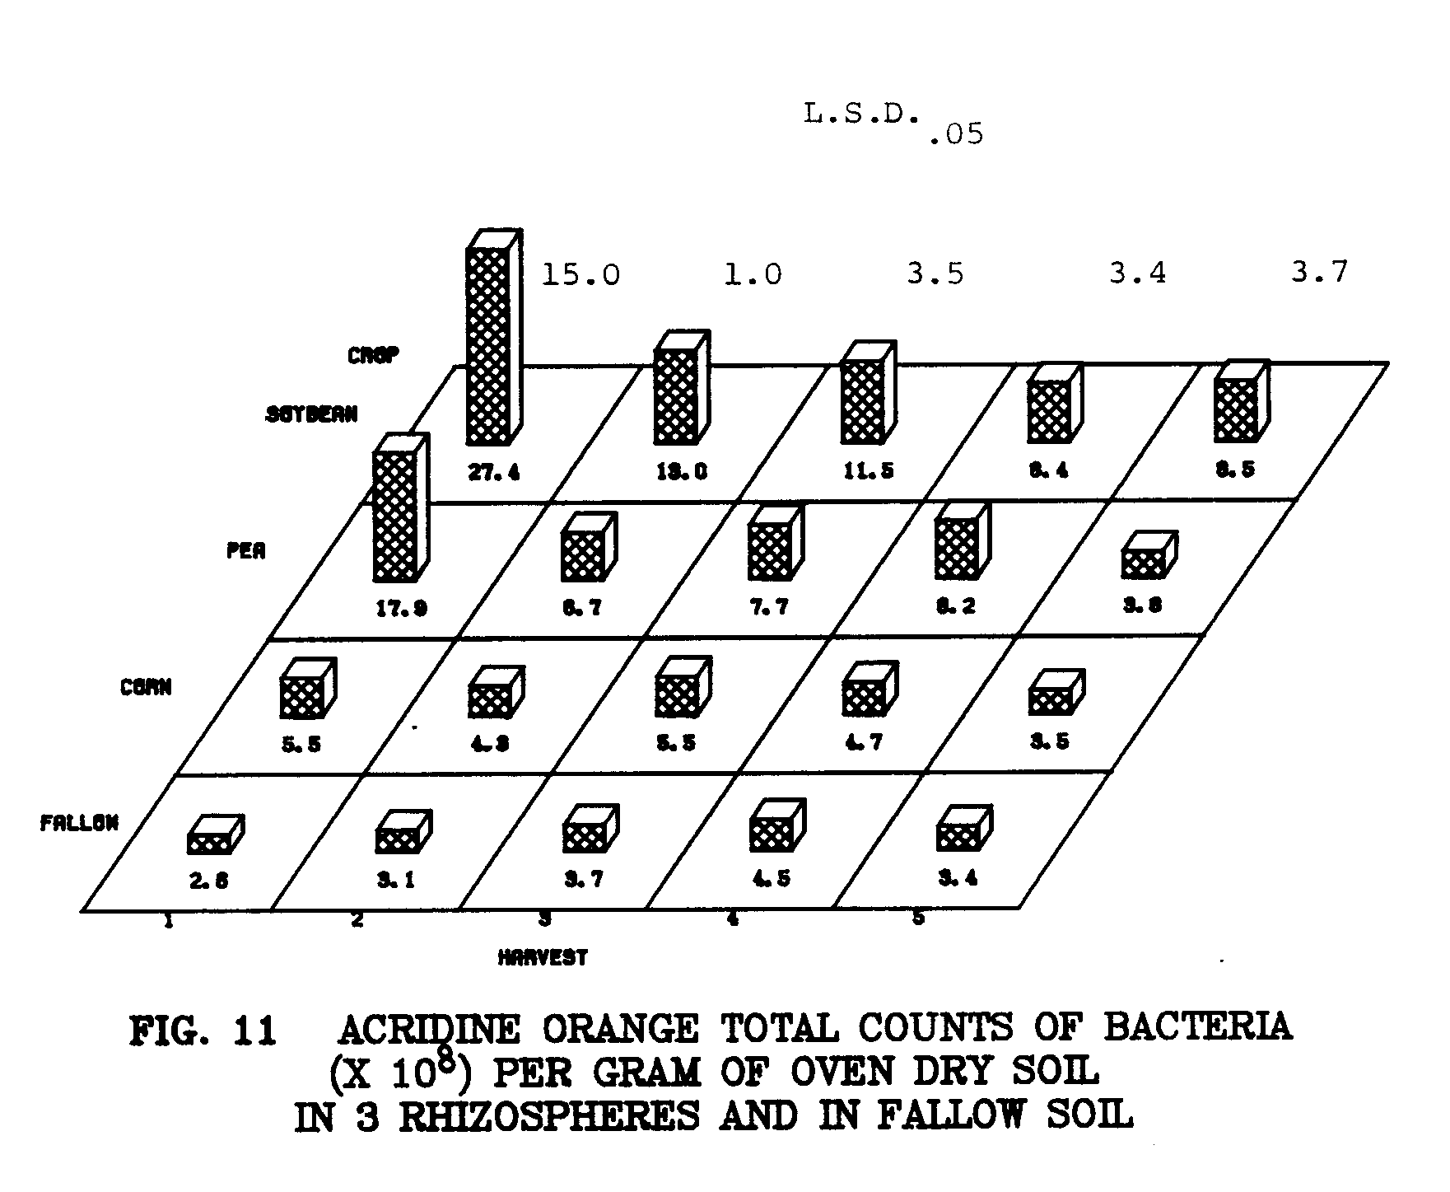
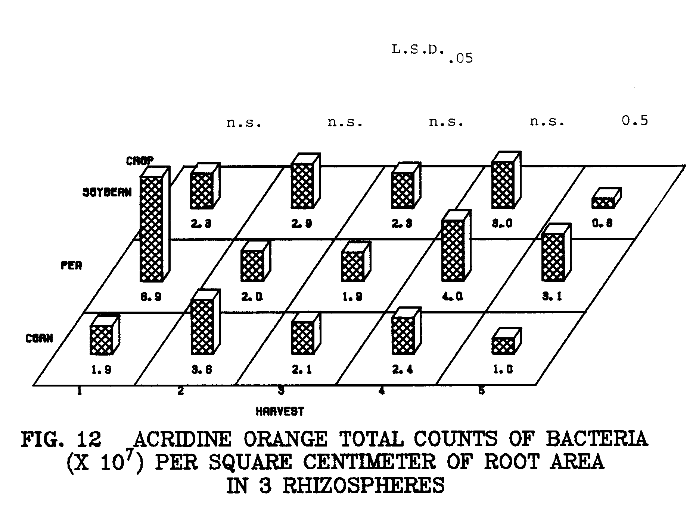
of 7%. Large and small nodules formed on pea plants. Large nodules were elongated and red inside. Small nodules were nearly spherical, and white throughout. Large and small nodules contained the two inoculant R. leguminosarum strains as well as an unidentified strain or strains as outlined in Figures 14 and 15. Mixed infections occurred in large and small pea nodules at an average of 10 and 5%, respectively.
Photographs of the experiment are presented at 1, 3, and 5 weeks in Figures 16, 17, and 18.

FIG. 16 VIEW OF THE EXPERIMENT AT 1 WEEK. GROWTH OF THE
EXPERIMENTAL PLANTS WAS UNIFORM WITHIN EACH SPECIES,
AND WITHIN AND BETWEEN REPLICATE POTS.

FIG. 17 VIEW OF THE EXPERIMENT AT 3 WEEKS. PLANTS GREW WELL
DESPITE THE CONFINEMENT OF THEIR ROOT SYSTEMS BY CORES.
CORN PLANTS ARE STARTING TO SHOW NITROGEN DEFICIENCY
SYMPTOMS (CHLOROSIS OF OLDER GROWTH), WHEREAS
THE LEGUMES ARE GREEN AND HEALTHY.

FIG. 18 VIEW OF THE EXPERIMENT AT 5 WEEKS. AT 5 WEEKS, PEAS
WERE FILLING PODS AND SOYBEANS HAD FLOWERED. THE NITROGEN
DEFICIENCY OF CORN WAS MORE PRONOUNCED, AS OLDER
LEAVES WERE SEVERELY CHLOROTIC OR NECROTIC.
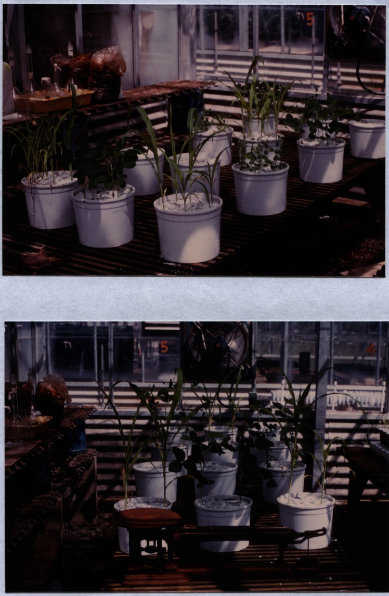
DISCUSSION

One of the factors proposed as a possible contributor to specificity in the Rhizobium-legume symbiosis is the selective stimulation of the homologous Rhizobium species in the rhizosphere of its homologous host (3,10). In the previous study (Chapter 2) I found that species of rhizobia were not specifically stimulated in the rhizospheres of their host at 35 days. I designed this study to examine the population dynamics of rhizobia in host and non-host rhizospheres at weekly intervals during the growth of the plants. Reyes and Schmidt (13) suggested that root surface area might be a better basis for expressing rhizosphere populations of rhizobia, so root area was estimated, and data presented on the basis of root area as well as soil weight.
As was seen previously (Chapter 2), rhizosphere stimulation of host and non-host rhizospheres was dependent more on the Rhizobium strains than on the particular species of Rhizobium. At l, 2, and
3 weeks, numbers per gram of soil of the strains were in the following order: soybean rhizosphere>pea>corn>non-rhizosphere soil (Figs. 1 to 3). Differences between crops at these harvests were all significant at the .05 level. At harvests 4 and 5 soybean rhizosphere numbers decreased (Figs. 4 and 5). At harvest 5 both pea and corn rhizospheres harbored significantly more rhizobia of all strains than the soybean rhizosphere (Fig. 5). This sharp decline of all strains in the soybean rhizosphere might be an artifact of having grown the plants in cores. At 4 and 5 weeks much of the soybean root system had emerged from the bottom of the cores, and roots proliferated rapidly in the bottom of the pots. The lowered numbers in the rhizospheres of peas and soybeans at 5 weeks probably reflect the fact that roots were growing rapidly, and enmeshing rhizosphere soil faster than the growth of the inoculant strains could keep up.
Differences in rhizosphere populations of rhizobia in the rhizospheres of the three crops were harder to detect on the basis of root surface area. Patterns of rhizosphere colonization were similar to those observed when rhizosphere populations were examined on a soil weight basis (Figs. 6 to 10). Significant differences between crops were only observed at 2 and 5 weeks (Figs. 7 and 10). Variability between root surface area estimations was high. This variability precluded the detection of differences between Rhizobium numbers in the rhizospheres of the three crops for harvests 1, 3, and 4 (Figs. 6, 8, and 9). Significant differences were observed between strains on the basis of root surface area across the five harvests, however differences were not indicative of specific stimulation (Figs. 6 to 10). As was seen previously (Chapter 2), numbers of the two R. japonicum strains were generally similar, and similar to numbers of R. leguminosarum strain Nitragin 92A3. R. leguminosarum strain Hawaii 5-0, however, is seen in significantly lower numbers than the other three strains in all rhizospheres and across all five harvests (Figs. 1 to 10). This would indicate rhizosphere colonization more on the basis of differences between strains, rather than species differences, with Hawaii 5-0 being less adapted to the conditions in the rhizospheres of all plants.
As was seen previously (Chapter 2), soybean nodule occupancy data approximated the rhizosphere counts of USDA 110 and CB 1809, as neither dominated (Fig. 13). In large pea nodules, Nitragin 92A3 dominated Hawaii 5-0 with the exception of harvest 2, when percentages of the two strains were nearly equal (Fig. 14). Nodule occupancy of small pea nodules was different. At harvest 3, both inoculant strains occupied nodules in approximately equal percentages, and unidentified bacteroids occupied a nearly equal percentage (Fig. 15). However, Hawaii 5-0 occupied more small nodules than Nitragin 92A3 at harvests 4 and 5, and at harvest 5 unidentified bacteroids predominated (Fig. 15).
Hawaii 5-0 has been shown to be very competitive in nodulating lentils in many tropical soils, including an Inceptisol (S. N. May, M.S. Thesis, 1979, University of Hawaii). However, Hawaii 5-0 was not as competitive as Nitragin 92A3 in nodulating peas. Perhaps the soil or host plant influence the competition between strains for nodulation of legumes.
Plants grew well in the Kula soil, despite having their root systems confined to cores. Lack of uniformity within or between replicates was not a problem (Figs, 16, 17, and 18). At 5 weeks, the corn was slightly chlorotic relative to the legumes, probably due to a nitrogen deficiency, as no amendments (other than rhizobia) were made to the soil (Fig. 18).
In this study, no evidence was found in support of specific stimulation of R. japonicum in the rhizosphere of soybeans or R. leguminosarum in the rhizosphere of peas. Rhizosphere colonization by rhizobia reflected more strain differences than species differences.
Rhizosphere numbers of rhizobia were quite high in the soybean and pea rhizospheres at 1 week, increasing from about 4 - 5 x 10⁵ per gram of moist soil at zero time to 1 - 2 x 10⁷ per gram of oven dry soil at 1 week. Although no specific responses were observed on the basis of rhizosphere growth during this study, it is possible that specific interactions occurred before the first sampling time, at 1 week. This possibility will be investigated in a later experiment.
LITERATURE CITED

1. Bohlool, B. B. and E. L. Schmidt. 1973. A fluorescent antibody technique for determination of growth rates of bacteria in soil. Bull. Ecol. Res. Comm. (Stockholm) 17:229-236.

2. Broughton, W. J. 1978. Control of specificity in legume-Rhizobium associations. J. Appl. Bacteriol. 45:165-194.

3. Brown, Margaret E., R. M. Jackson, and S. K. Burlingham. 1968. Growth and effects of bacteria introduced into soil. In
T. R. G. Gray and D. Parkinson (Eds.) The ecology of soil bacteria. Liverpool Univ. Press, Liverpool. pp. 531-551.

4. Carlson, J. B. 1969. Estimating surface area of soybean root systems. J. Minn. Acad. Sci. 36:16-19.

5. Van Egeraat, A. W. S. M. 1975. The growth of Rhizobium leguminosarum on the root surface and in the rhizosphere in relation to root exudates. Plant and Soil 42:367-379.

6. Graham, Terrence L. 1981. Recognition in Rhizobium symbioses. In Kenneth L. Giles and Alan G. Atherly (Eds.) Biology of the Rhizobiaceae. Academic Press, Inc., New York.

7. Ham, G. E., L. R. Frederick, and L. C. Anderson. 1971. Serogroups of Rhizobium japonicum in soybean nodules sampled in Iowa. Agron. J. 63:69-72.

8. Kingsley, Mark T. and B. B. Bohlool. 1981. Release of Rhizobium spp. from tropical soils and recovery for immunofluorescence enumeration. Appl. Environ. Micro. 42:241-248.

9. MacGregor, A. N. and M. Alexander. 1972. Comparison of nodulating and non-nodulating strains of Rhizobium trifolii. Plant and Soil 36:129-139.

10. Nutman, P. S. 1965. The relation between nodule bacteria in the rhizosphere and in the process of infection. In K. F. Baker and W. C. Snyder (Eds.) The ecology of soil-borne plant pathogens.
pp. 231-247. Univ. Calif. Press, Berkeley.

11. Peters, R. J. and M. Alexander. 1966. Effect of legume exudates on the root nodule bacteria. Soil Sci. 102:380-387.

12. Reyes, V. G. and E. L. Schmidt. 1979. Population densities of Rhizobium japonicum strain 123 estimated directly in soil and rhizospheres. Appl. Environ. Micro. 37:854-858.

13. Reyes, V. G. and E. L. Schmidt. 1981. Populations of Rhizobium japonicum associated with the surfaces of soil-grown roots. Plant and Soil 61:71-80.
14. Rovira, A. D. 1961. Rhizobium numbers in the rhizosphere of red clover and paspalum in relation to soil treatment and numbers of bacteria and fungi. Aust. J. Agric. Res. 12:77-83.

15. Schmidt, E. L. 1974. Quantitative autoecological study of microorganisms in soil by immunofluorescence. Soil Sci. 118:141-149.

16. Schmidt, E. L. 1978. Ecology of the legume root nodule bacteria. pp. 269-303. In Y. R. Dommergues and S. V. Krupa (Eds.) Interactions between non-pathogenic soil microorganisms and plants. Elsevier Scientific Publishing Co., Amsterdam.

17. Schmidt, E. L. and B. B. Bohlool. 1981. The role of lectins in plant-microbe interactions. pp. 658-677. In W. Tanner and F. A. Loewus (Eds.) Encyclopedia of plant physiology, New Series, Vol. 4. Plant carbohydrates II. Springer-Verlag, Berlin, Heidelberg.

18. Vincent, J. M. 1970. A manual for the practical study of root nodule bacteria. International Biological Programme Handbook no. 15. Blackwell Scientific Publications, Oxford, England.

19. Vincent, J. M. 1974. Root nodule symbiosis with Rhizobium.
pp. 265-341. In Quispel (Ed.) The biology of nitrogen fixation. North Holland Publishing Co., Amsterdam.

CHAPTER 4
RHIZOBIUM POPULATION DYNAMICS IN HOST AND NON-HOST RHIZOSPHERES
DURING THE FIRST NINE DAYS OF RHIZOSPHERE DEVELOPMENT
ABSTRACT

The growth of two R. japonicum strains (USDA 110 and CB 7809) and two R. leguminosarum strains (Hawaii 5-0 and Nitragin 92A3) was followed in non-sterile rhizospheres. In one study, growth of these strains was followed in the rhizospheres of soybeans and peas at planting, 24, and 48 hours, and rhizosphere growth rates estimated. Mean doubling times for the strains were 12 to 13 hours in the soybean rhizosphere and 9 to 11 hours in the pea rhizosphere. Total counts of bacteria measured by acridine orange staining indicated that other bacteria were not as strongly stimulated by the rhizosphere as rhizobia in the early stages of plant growth. In another study, rhizosphere populations of the four strains were followed in the rhizospheres of soybeans, peas, and corn, as well as in non-rhizosphere soil at 3, 5, 7, and 9 days. Rhizosphere numbers of Rhizobium increased from their starting levels of 4 - 9 x 10⁵ per gram of moist soil to 1 - 2 x 10⁷ per gram of moist soil at 3 days, and declined thereafter. Populations of bacteria enumerated with acridine orange remained relatively constant. This early burst of the growth of rhizobia might indicate that they responded faster to the conditions of the rhizosphere than the bacterial population at large, but were diluted out as the root systems expanded rapidly. No specific stimulation of the growth of rhizobia was detected in the rhizospheres of their host plants. Rhizosphere populations reflected strain differences more than species differences, in all crops and at all harvests.
INTRODUCTION

Soil bacteria of the genus Rhizobium are distinguished from other genera by their ability to form nitrogen-fixing nodules on the roots of leguminous plants. Rhizobia are specific with respect to the hosts they nodulate. Only certain species of Rhizobium are able to infect and nodulate the roots of particular legumes. Although the relationship between host and bacterium has been studied in great detail, the basis for this specificity is not completely clear (1,7).
One proposed mechanism as a possible contributor to specificity is the preferential growth of the appropriate Rhizobium in the rhizosphere of its homologous host plant over other soil bacteria and rhizobia (2,4,9).
In studies described earlier (Chapters 2 and 3), rhizosphere numbers of four Rhizobium strains were determined at harvest across four 35-day harvests, as well as at weekly intervals during one 35-day growth cycle. I observed no specific stimulation of growth of Rhizobium species in the rhizospheres of their homologous host plants in these studies. When rhizosphere populations were sampled once a week, numbers of all strains increased from their starting levels of about 4 x 10⁵ per gram of soil to a level of about 1 x 10⁷ per gram of soil at 1 week, and generally declined thereafter.
Following is the description of two experiments in which population dynamics of homologous and non-homologous rhizobia were followed in the rhizospheres of host and non-host plants. Rhizosphere populations were sampled in one study at planting, 24, and 48 hours, and in another study at 3, 5, 7, and 9 days.
MATERIALS AND METHODS

Inoculum Preparation and Rhizobium Strains
Fresh Kula loam soil, prepared as described previously, was used for the 9-day time course study. Initial levels of each of the strains per gram of moist soil were as follows, as determined by immunofluorescence: R. japonicum USDA 110, 8.3 x 10⁵ and CB 1809, 9.2 x 10⁵, R. leguminosarum Nitragin 92A3, 4.2 and 10⁵ and Hawaii 5-0, 3.9 x 10⁵. For the early rhizosphere growth rate study, about 5 x 10⁹ cells of each strain (as estimated by optical density) were transferred from yeast-extract mannitol broth (8) culture and blended with 2000 grams of fresh Kula soil, to give about 2.5 x 10⁶ cells per gram of moist soil. This intermediate dilution was blended with more moist Kula soil, 275 g of intermediate dilution to 5225 g of bulk soil. This 1:20 dilution was expected to give about 1.25 x 10⁵ cells per gram of moist soil. Actual starting numbers at planting were slightly higher than this estimate, as follows: USDA 110, 4.3 x 10⁵, CB 1809, 5.1 x: 10⁵, Nitragin 92A3, 4.3 x 10⁵ and Hawaii 5-0, 4.7 x 10⁵. Strains were obtained from the collection of B. B. Bohlool of the University of Hawaii, and were grown and maintained as described previously.

Pots and Planting
Pots were 25 cm in diameter and 20 cm high, and were painted with a heavy coat of flat white paint. Each was filled with 5.5 kg of
moist Kula soil. Into each pot was planted 80 seeds. Soybeans (Davis), peas (Wilt-resistant Wisconsin Perfection), and sweetcorn (Hawaiian Supersweet #9) were the crops. In the growth rate study, only peas and soybeans were planted. Seeds were not pregerminated. Following planting, the soil surface was covered with rinsed white aquarium gravel to prevent undue soil heating and the growth of algae. Deionized water was added to bring the soil to a moisture tension of about -1/3 bars.
Soil moisture tension was maintained at about -1/3 bars by watering to constant weight with deionized water. Each experiment was set up as a randomized complete block in three replications and carried out in a greenhouse under natural lighting conditions. Soil temperature during the afternoon was about 30⁰C.

Harvest and Sample Preparation
For the 9-day time course, I harvested 15 to 20 plants from each pot at 3, 5, 7, and 9 days after the planting of dry seeds. Forty plants were dug out (by hand) from each pot at 24 and 48 hours in the growth rate study. Rhizosphere soil was considered to be that which adhered to seeds and root system after gentle shaking. Plants and root systems were placed into 18-ounce Whirlpak bags for transport to the laboratory. A sample of approximately 10 grams was removed from the non-rhizosphere soil pots at each time point during the 9-day time course. Ten-gram samples were removed from pea and soybean pots immediately before the planting of the growth rate study.
Bacteria were released from root surfaces and rhizosphere soil particles for enumeration as previously described (Chapter 2). At harvest 1 of the 9-day time course, 50 ml of the extractant mixture (3) was used rather than 100 ml, because of the small amount of rhizosphere soil present. Twenty and 50 ml of extractant were used for the 24- and 48-hour enumerations, respectively, of the growth rate study.

Membrane Filter Immunofluorescence and Acridine Orange Total Counts
Membrane filter counts were performed as described by Kingsley and Bohlool (3). Duplicate filters were counted for each strain from each pot, for a total of 96 filters per harvest in the 9-day time course and 48 per harvest of the growth rate study.
I made acridine orange counts at each harvest as previously described (Chapter 2). Three filters were counted per pot, for a total of 36 per harvest in the time course and 18 per harvest in the growth rate study.
RESULTS

Rhizosphere numbers of each of the four inoculant strains are presented at 3, 5, 7, and 9 days in Figures 1 to 4. Acridine orange total counts at the above time points are presented in Figure 5.
Populations of each of the four inoculant strains are presented at planting, 24, and 48 hours in the pea and soybean rhizospheres in Figures 6 and 7. Estimates of mean doubling times of inoculant strains are also presented in Figures 6 and 7. At 24 hours, soybeans had radicles about 1 cm long, and peas were swollen, but radicles had not yet extended. At 48 hours, soybeans and peas had radicles of about 6 cm and 1 cm, respectively. Rhizosphere populations of bacteria estimated by acridine orange total counts are presented at planting, 24, and 48 hours in Figure 8.
Percentages of Rhizobium (the four inoculant strains combined) in the rhizosphere population of bacteria are given for each study in Tables 1 and 2, respectively.
Nodules were not observed on the roots of the legumes, due to the short duration of the experiment.
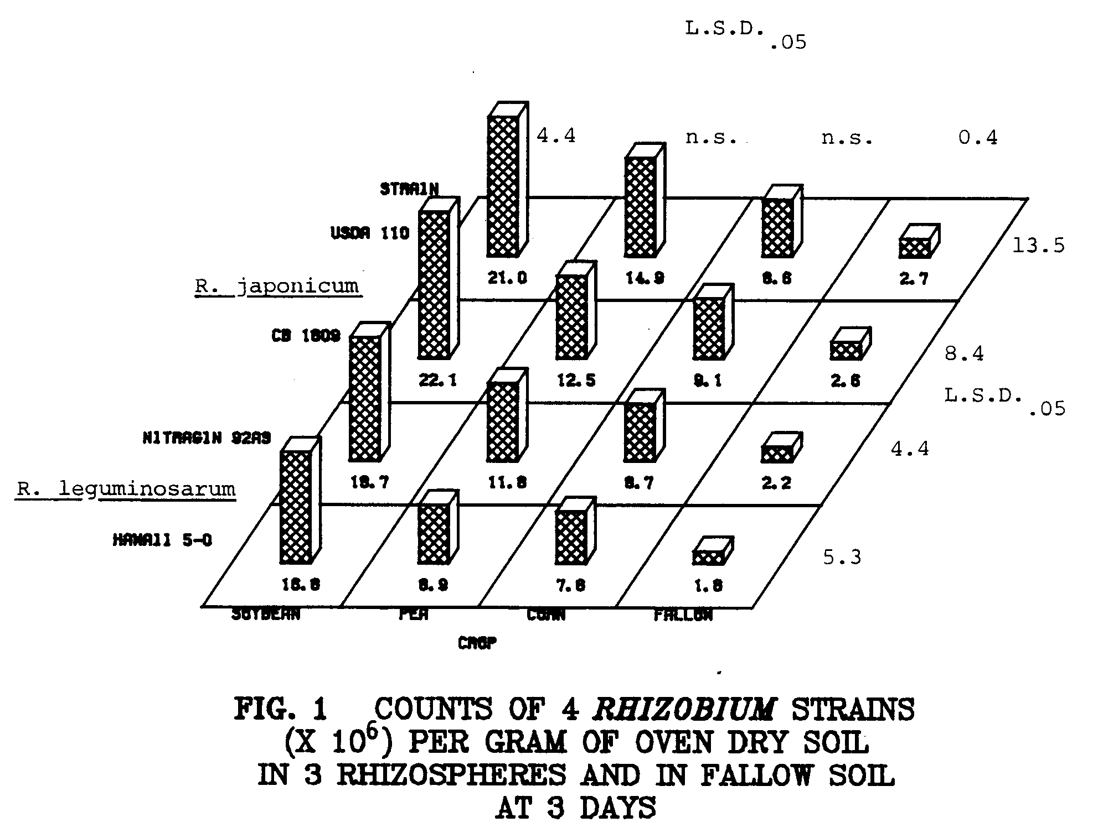
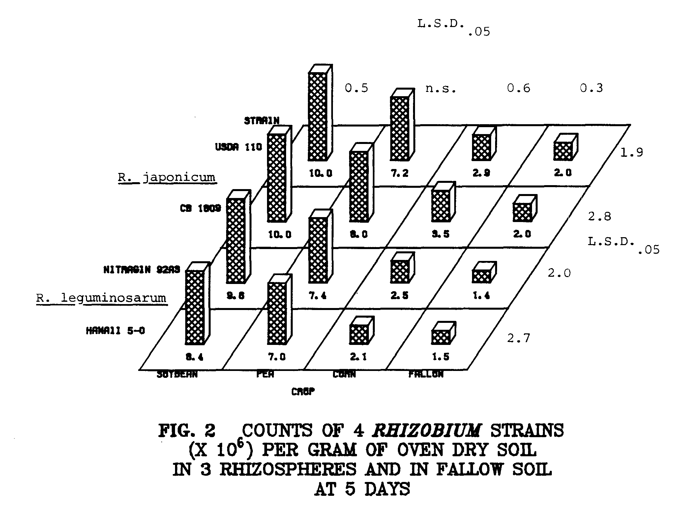
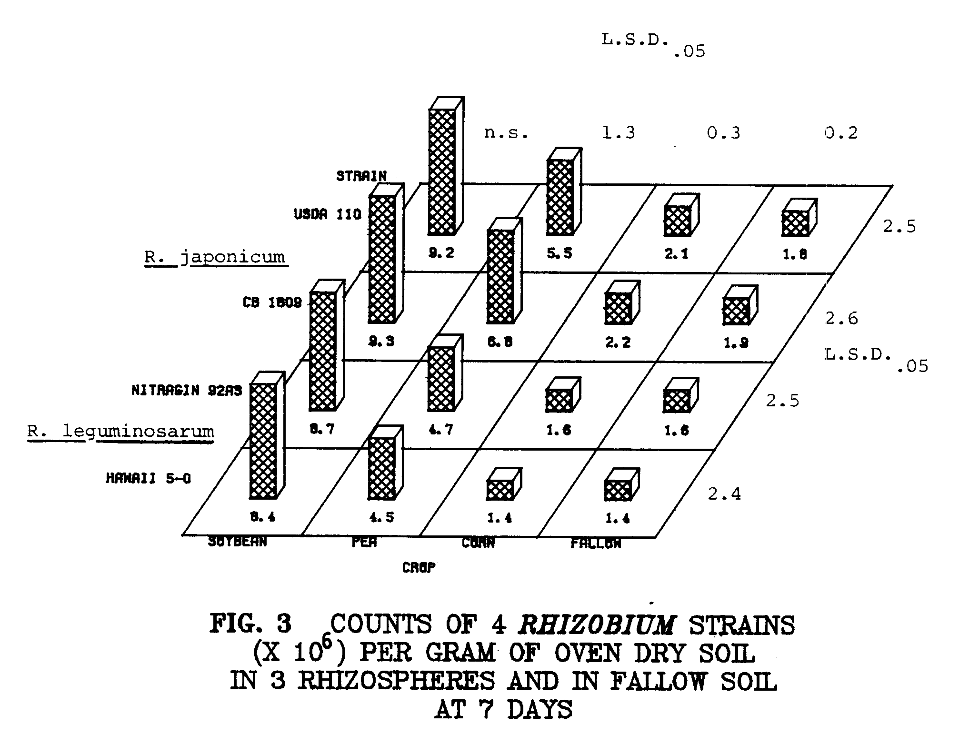
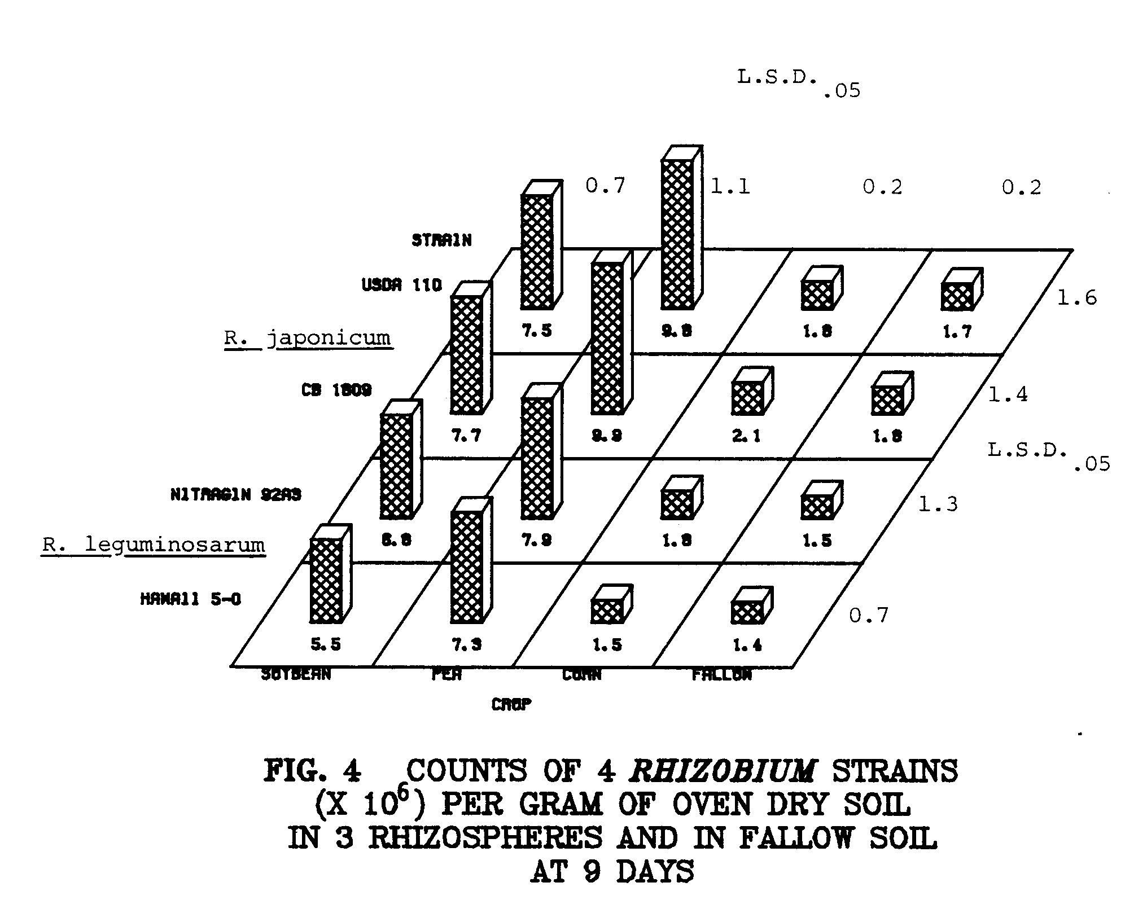
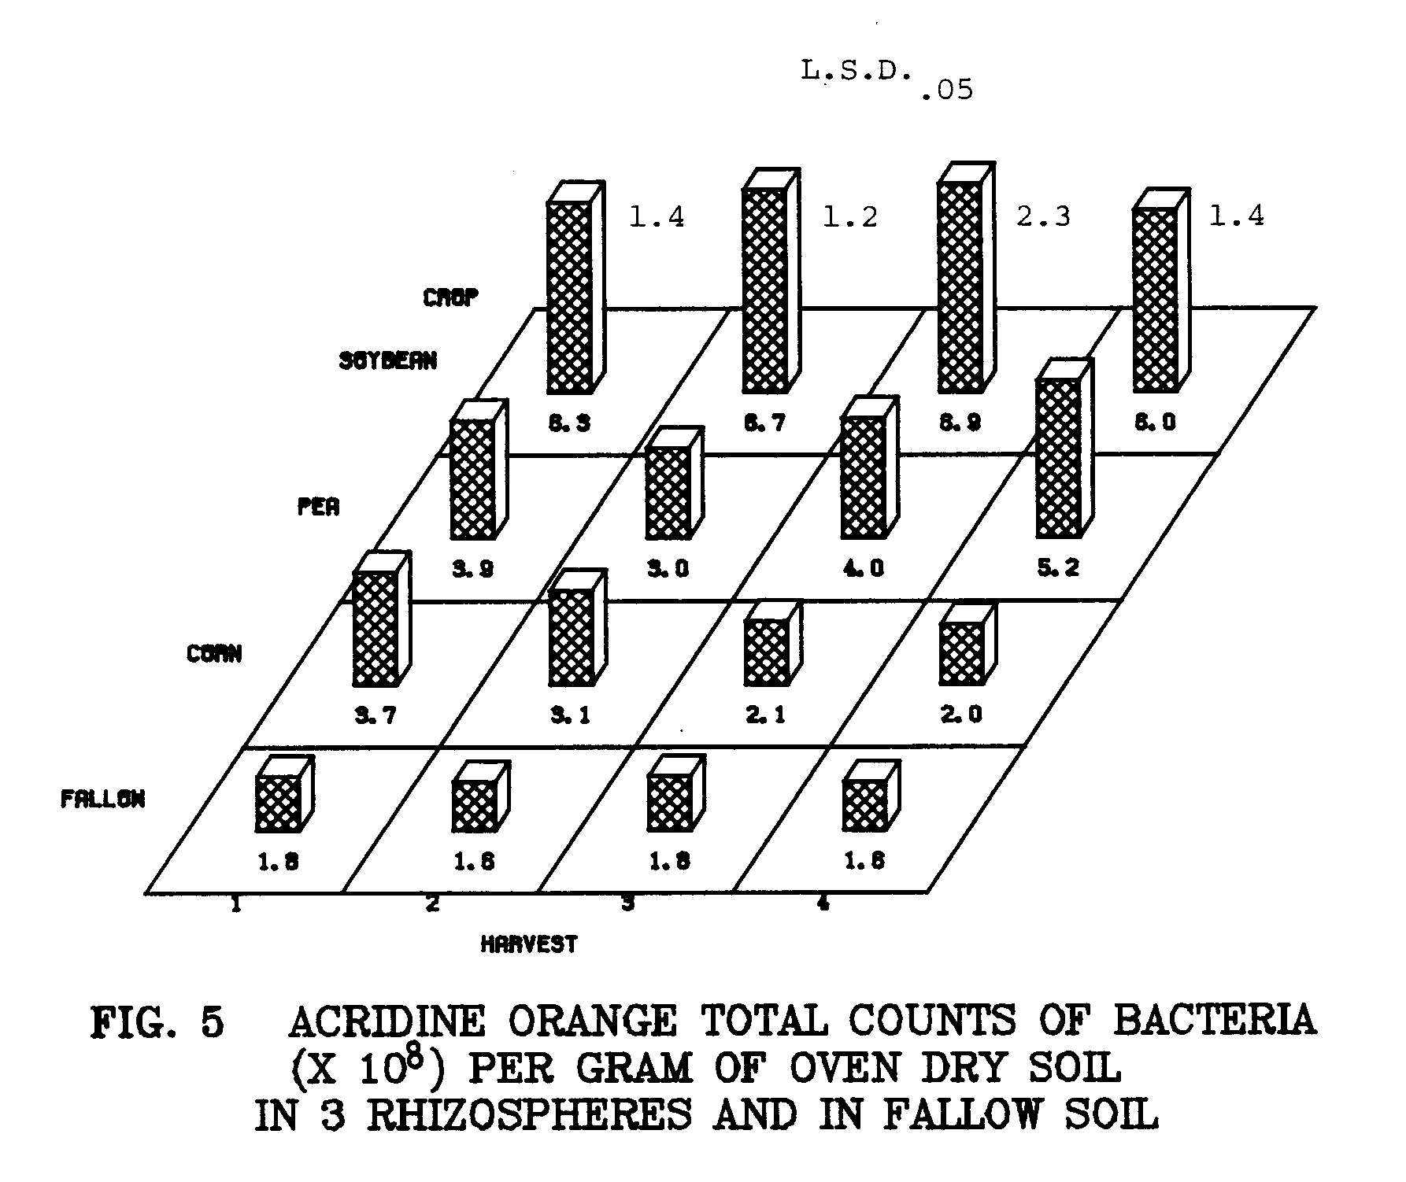
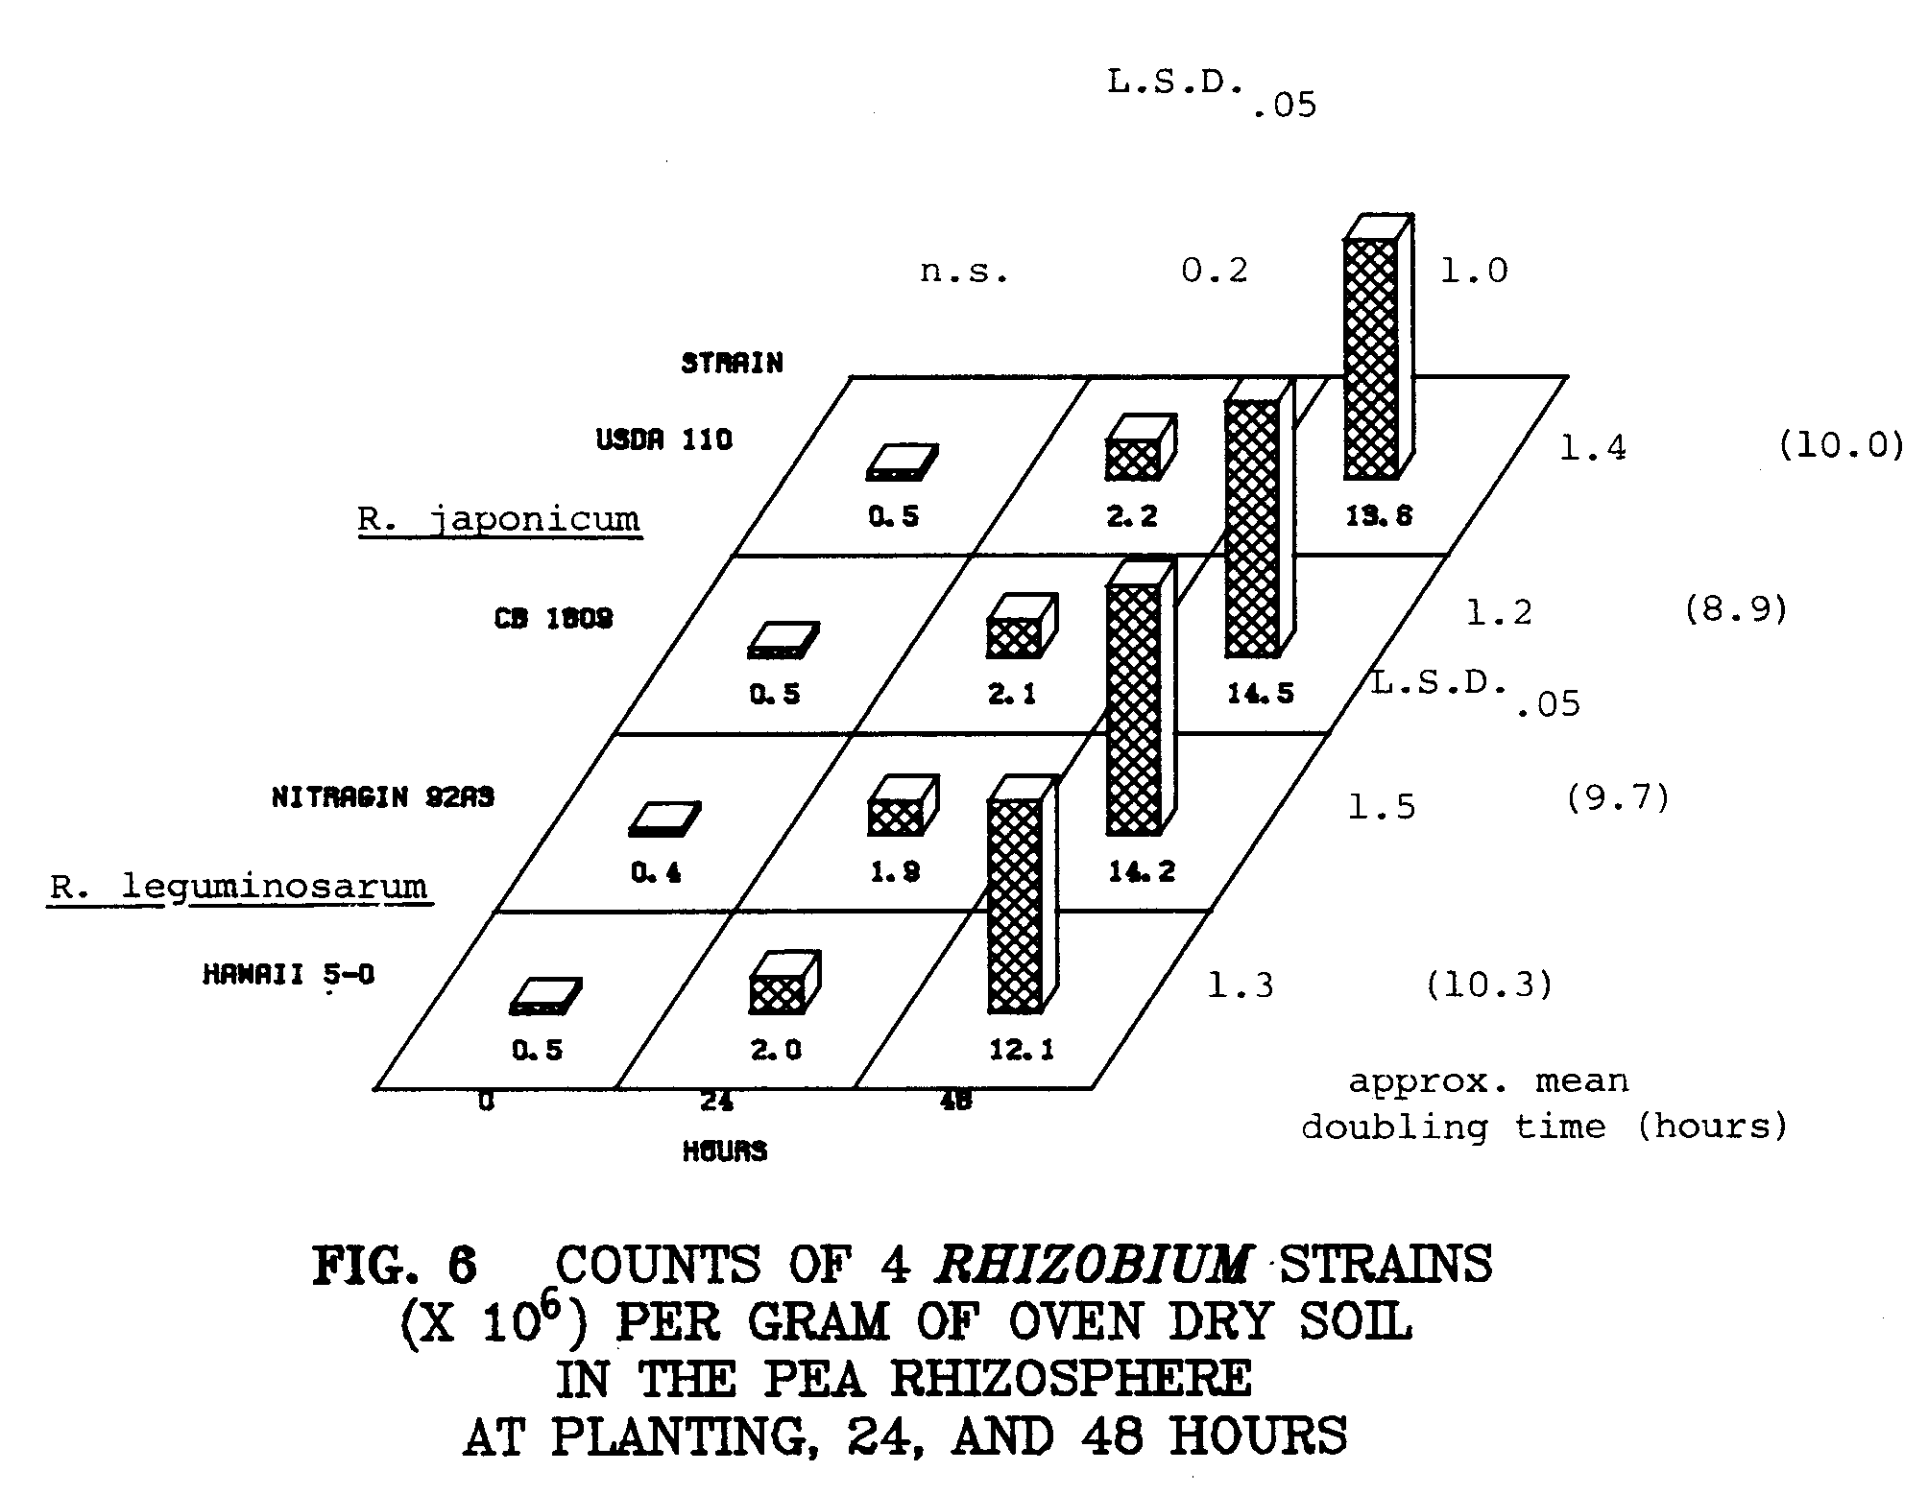
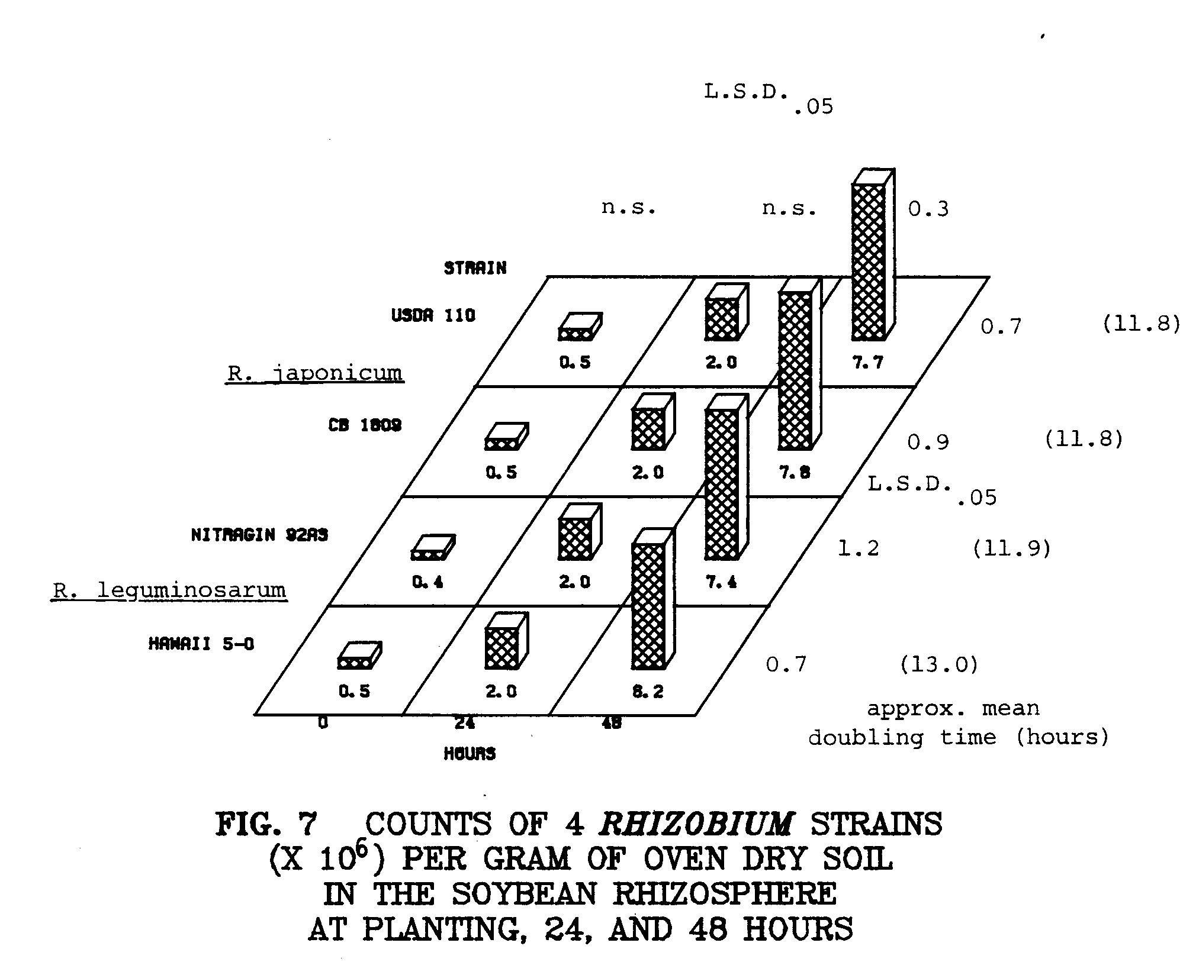
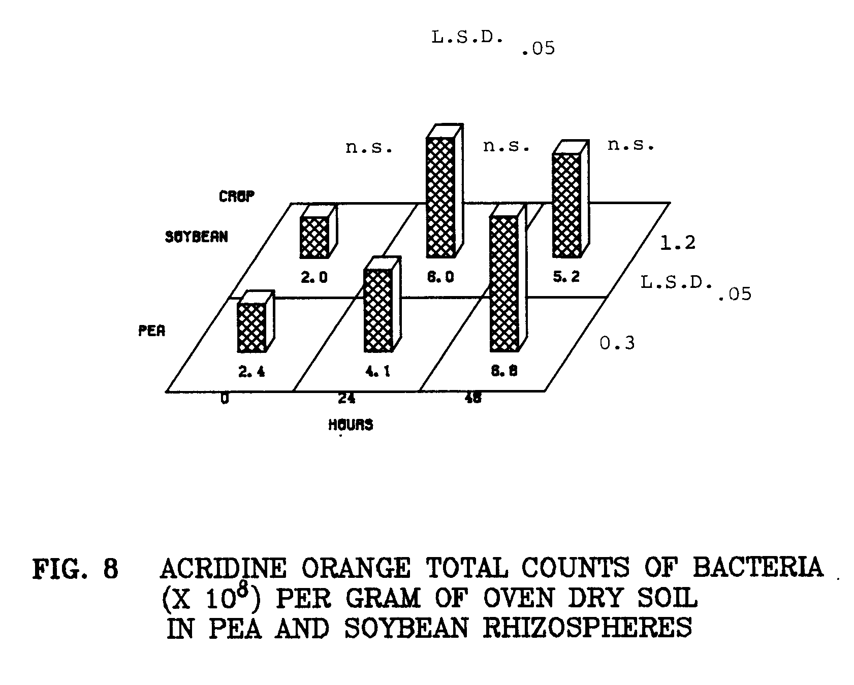
DISCUSSION

Specific stimulation in the rhizosphere is proposed as a possible contributor to specificity in the Rhizobium-legume symbiosis (2,4,9). In two earlier studies (Chapters 2 and 3), population dynamics of two R. japonicum and two R. leguminosarum strains was followed in host and non-host rhizospheres. I sampled rhizosphere populations at 35 days in one experiment and at weekly intervals during one 35-day growth cycle in another. In these studies, as well as those of Reyes and Schmidt (5,6) on the soybean R. japonicum strain 123 association, no specific stimulation was detected in the rhizosphere.
Rhizosphere numbers of rhizobia were in the following order: soybean>pea>corn at 3, 5, and 7 days, although differences between rhizosphere populations between crops were not always significant (Figs. 1 to 3). At 9 days, pea rhizosphere numbers of all strains significantly surpassed those for soybean, with the exception of strain Nitragin 92A3 (Fig. 4). Rhizobia per gram of soybean rhizosphere soil declined over the four harvests (Figs. 1 to 4). In the pea rhizosphere rhizobia declined for the first week (Figs. 1 to 3), then increased slightly at 9 days (Fig. 4). Numbers of Rhizobium per gram of corn rhizosphere soil were rarely significantly different from numbers in non-rhizosphere soil at 3, 5, 7, and 9 days. As was seen in Chapters 2 and 3, numbers of the two R. japonicum strains were nearly equal in any particular rhizosphere at any given harvest. Rhizosphere numbers of Hawaii 5-0 were sometimes significantly lower than numbers of the other three inoculant strains, but differences were usually slight, less than the two-fold differences seen in Chapter 2 (Figs. 1 to 4). Apparently the competitive advantage of the other strains over Hawaii 5-0 was not as great during early development of the rhizosphere.
In the growth rate study, rhizobia responded rapidly to the conditions of the rhizosphere, and numbers of each strain increased about 1 1/2 logs in the first 48 hours (Figs. 6 and 7). Growth rates in the early rhizosphere were roughly equal for both the fast-growing (R. leguminosarum) and the slow-growing (R. japonicum) strains. This suggests that there might be limiting nutrients or growth factors which restrict the growth of rhizobia, regardless of their growth rate in broth culture.
The soybean rhizosphere did not specifically stimulate the growth of R. japonicum, nor did the pea rhizosphere specifically stimulate R. leguminosarum (Figs. 1 to 4, 6 and 7). In the 9-day time course, as
was seen previously (Chapter 3) numbers of all inoculant strains of rhizobia in all rhizospheres were highest at the first time point (3 and 7 days for the two studies, respectively). At 3 days rhizobia comprised their highest percentages of the rhizosphere population of bacteria, relative to acridine orange total counts (Tables 1 and 2).
It appears that rhizobia responded to the conditions of the early rhizosphere with a burst of rapid growth. Rhizobia multiplied rapidly in the developing seedling rhizosphere, and reached peak populations,
on the basis of soil weight, even before the emergence of shoots from the soil. Thus, the early events in the rhizosphere may play an important role in the nodulation of legumes, as proposed by Kosslak, Dowdle, Sadowsky, and Bohlool (8th North American Rhizobium Conference, 1981. Abstracts). However, patterns of growth do not reflect selective stimulation of rhizobia by their homologous hosts (Figs. 1 to 4, 6 and 7). Soybean and pea rhizospheres stimulated the growth of rhizobia more strongly than the corn rhizosphere during the first nine days of growth (Fig. 1). This was also the case for bacteria in general (Fig. 5).
Rhizobial numbers declined after this initial burst of growth, probably because the plant root systems expanded and enmeshed soil faster than rhizobia could colonize it.
These data support the work of Reyes and Schmidt (5,6), who examined the growth of R. japonicum strain 123, a highly competitive soybean strain, both on the basis of rhizosphere soil weight (5) and on the basis of root surface area (6). They found no evidence to support the concept of specific stimulation as a possible contributor to specificity. In the first study (5), rhizosphere numbers of strain 123 per gram of soil peaked at 21 days, and declined at 28 days. In the second experiment (6), they observed a decline in numbers of strain 123 in the soybean rhizosphere between days 16 and 30, on the basis of root area. Reyes and Schmidt (6) postulated that the rhizosphere population of strain 123 is unable to keep up with the rapidly-expanding soybean root system.
It is possible that specific stimulation might have occured at microsites along the plant root system. If this were the case, the rhizosphere sampling and enumeration methodology such as the one used for these studies might be inadequate to detect the stimulation. This highly localized stimulation seems unlikely for the case of the soybean rhizosphere, however. Reyes and Schmidt (6) examined soil adhering to unwashed soybean roots and found populations of two strains of R. japonicum to be uniform and low (6).
Acridine orange total counts were relatively constant throughout the 9-day time course (Fig. 5). An early burst of growth of bacteria was observed in the first 48 hours. Rhizobia grew more rapidly than the other soil bacteria, but because of the high initial numbers of other bacteria, they always comprised the vast majority of the rhizosphere population (Tables 1 and 2). This early burst of growth was not specific with respect to legume host or Rhizobium species. However, this early burst of growth in the rhizosphere might be a factor in ensuring the successful establishment of the Rhizobium-legume symbiosis.
LITERATURE CITED

1. Broughton, W. J. 1978. Control of specificity in legumeRhizobium associations. J. Appl. Bacteriol. 45:165-194.

2. Brown, Margaret E., R. M. Jackson, and S. K. Burlingham. 1968. Growth effects of bacteria introduced into soil. In T. R. G. Gray and D. Parkinson (Eds.) The ecology of soil bacteria. Liverpool Univ. Press, Liverpool. pp. 531-551.

3. Kingsley, Mark T. and B. B. Bohlool. 1981. Release of Rhizobium spp. from tropical soils and recovery for immunofluorescence enumeration. Appl. Environ. Micro 42:241-248.

4. Nutman, P. S. 1965. The relation between nodule bacteria in the rhizosphere and in the process of infection. In K F. Baker and W. C. Snyder (Eds.) The ecology of soil-borne plant pathogens.
pp. 231-247. Univ. Calif. Press, Berkeley.

5. Reyes, V. G. and E. L. Schmidt. 1979. Population densities of Rhizobium japonicum strain 123 estimated directly in soil and rhizospheres. Appl. Environ. Micro. 37:854-858.

6. Reyes, V. G. and E. L. Schmidt. 1981. Populations Rhizobium japonicum associated with the surfaces of soil-grown roots. Plant and Soil 61:71-80.

7. Schmidt, E. L. 1978. Ecology of the legume root nodule bacteria. pp. 269-303. In Y. R. Dommergues and S. V. Krupa (Eds.) Interactions between non-pathogenic soil microorganisms and plants. Elsevier Scientific Publishing Co., Amsterdam.

8. Vincent, J. M. 1970. A manual for the practical study of the root nodule bacteria. International Biological Programme Handbook no. 15. Blackwell Scientific Publications, Oxford, England.

9. Vincent, J. M. 1974. Root nodule symbiosis with Rhizobium.
pp. 265-431. In Quispel (Ed.) The biology of nitrogen fixation. North Holland Publishing Co., Amsterdam.

CHAPTER 5
GENERAL DISCUSSION
GENERAL DISCUSSION

From these data it would appear that specific stimulation in the rhizospheres of peas and soybeans of their homologous Rhizobium species was not seen under the conditions of these studies. Bacteria, including rhizobia, were generally more strongly stimulated by the soybean rhizosphere than the pea rhizosphere. The rhizosphere of sweetcorn harbored more bacteria than fallow soil, but less bacteria than the legume rhizospheres.
All strains grew rapidly in the early periods of rhizosphere development. Numbers peaked at about 3 days in the pea and soybean rhizospheres, and declined thereafter as the plant root systems expanded rapidly. Nodulation patterns reflected rhizosphere populations of the Rhizobium strains, but rhizosphere differences alone could not account for the differences in nodule occupancy.
Rhizosphere populations of Rhizobium reflected more strain differences than species differences. Perhaps rhizobia colonize rhizospheres without regard to plant species, and some strains are better rhizosphere colonizers than others.
Curiously, rhizosphere populations of each strain never got above about 2 - 3 x 10⁷ cells per gram of soil even when soil was continuously cropped with one plant species. Thus, it seems as though the rhizosphere might have a limited carrying capacity for Rhizobium.
The rapid early growth of Rhizobium in the rhizosphere was surprising. Although the growth of all inoculant strains was similar in the early rhizosphere in these experiments, this might not be the case for all strains in all rhizospheres.
Further work should concentrate on the documentation of the rapid growth of rhizobia in the early rhizosphere. It seems unlikely that this early growth would comprise a mechanism for host-bacterium specificity, but perhaps the competitive advantage of some strains over others is a result of rapid early growth in the rhizosphere.
The basis for specificity in the Rhizobium-legume association remains uncertain. In these studies, specific stimulation of Rhizobium species in the rhizospheres of their homologous host plants was not observed.

